Timesheets

Introduction
Time management is a fully integrated solution with a number of touch points throughout other modules. Its core purpose is to record the working time of each employee each day for audit with an option for further implementation in order to analyse the time spent on projects and specific tasks to potentially create documents within your organisation’s ERP system.

Each employee has the option to create a timesheet at a scale of one per week against their employment company and has the option of extending to one per week per group.

The week may begin on either a Monday or a Sunday but each week will run for a set 7 days and weekends/public holidays may be disabled to ensure no time is entered – all days visible, irrespective of if they are a non-working day or an absence may still have time recorded against them.

Creating
Starting from the menu item “This Week”, it will load the timesheet for the logged on user for the current week and pre-set the default group (if set). The user then has the option to change the date by selecting any date within the week they wish to view.

For managers and HR users, where the settings allow, an additional filter will be made available in order to toggle to another user’s timesheet which will load in the applicable state (such as draft and allowing for amendments or ready for approval).

Changing the group will perform one of two functions depending on how it is configured. If the system ALLOWS for multiple timesheets per week (each for a different group) then the timesheet will reload to the same user, same week but to the new group. If this option is not available the user will be prompted that the timesheet is about to be reset for the week which will clear the lines.

When multiple group timesheets are allowed the lines relating to the loaded group will be editable, all other group lines for the same user in the same week will be displayed BUT will be read-only. This enables a user and an approver to review the entire week for the employee before submitting or approving.

Once a timesheet for the week has been loaded it is at that point automatically created and loaded with a single line ready for entry. An option to enhance this loading so the line is pre-set with the hours required on each day based on the working pattern can be enabled but is only applicable to users who tend to only perform a single task per week. For those users there is also a “Copy Last Week” option which will duplicate the last timesheet entered prior to the current week (not necessarily the previous week as there may have been a gap in entry).
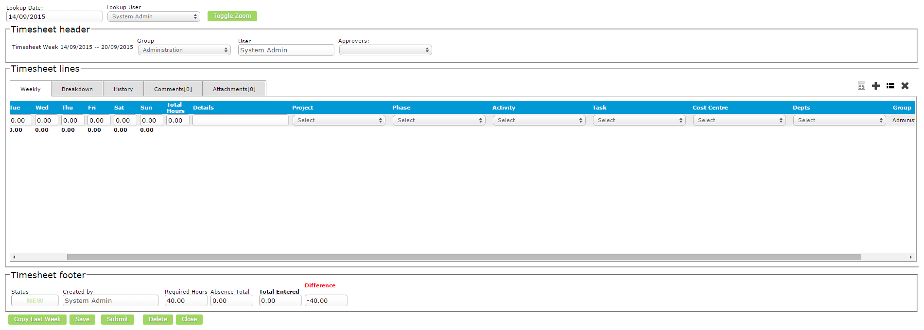

Whilst a timesheet is in a status of “New” or “Draft” it may be deleted to clear any clutter from the system but there is a configuration available on the working pattern which determines if a timesheet is required for all weeks for reviewing (see next section). This validation is based around the start date of the employee to the current date (so not to show weeks where the employee was not a member of the organisation).

Prior to submitting the timesheet, lines need to be added to it. There is no limit to the number of lines but it is expected that there only needs to be a single line per distinct analysis as the same line can be used for all days of the week. These lines may also be ticked for deletion and also copied to a new line should only a small change be required on the analysis. The options for each line are:
- Details – free text entry
- Project – directly from SAP OR from connected projects described below
- Phase – from connected projects described below (if enabled)
- Activity – described below
- Task – described below
- 5 SAP dimensions – as enabled
- Order header – if enabled, once a project is selected the related order from SAP for the project can also be loaded allowing for the timesheet hours to be linked to an order
- Order line – if enabled, once an order header is selected the related order lines will be displayed allowing for the timesheet hours to be linked to a specific line on an order

There is also a Calculator feature. Timesheets are ALWAYS recorded in hours to two decimal places but a user can optionally place the cursor in a day on a row (where the hours are entered) and click the Calculator button. The popup will allow for a start and end time to be entered which on saving will record the line in the “Breakdown” tab and then apply the additional hours to the text box where the cursor was placed. From the Breakdown, the records can be seen and removed which will then reduce the applicable hours.

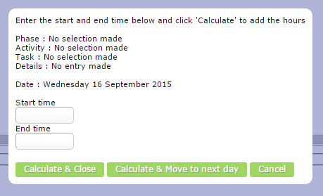
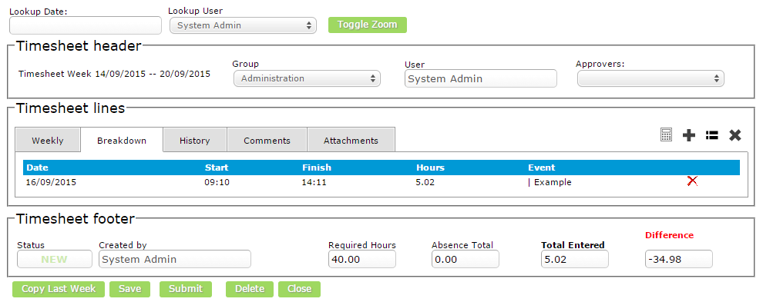

The timesheet footer shows the current status along with the following summaries:
- Required Hours – the total number of hours required for this week
- Absence Total – the total number of hours pre-allocated to leave, sick and public holidays
- Total Entered – the total hours entered for this week on the selected group
- Other Timesheets – the total hours entered for this week on OTHER groups and OTHER companies (if enabled)
- Difference – the missing/additional time (Required - Absence - Entered - Other = Balance)
- Flexi balance – the figure from the user profile showing the current APPROVED flexi accruals so the user knows if they are able to submit less this week or would need to make time up from previous weeks (if enabled)
On submitting the timesheet a number of validations are made (all of which can be disabled). Firstly the “Difference” above is assesed along with the working pattern rules on if a deficit or and excess entry is allowed or not. If not, the submission is cancelled otherwise the user is informed of the difference, if enabled, before the submission is accepted.

A final message is then presented to the user to confirm the week is ready for approval at which point the timesheet is routed as described below.

Approving
With each submitted timesheet the approval workflow and company settings are assessed in order to route the timesheet to the correct person or people. This is done via home page tasks and optionally via email alerting.

The statuses of a timesheet are as follows and with each, comments can be added and documents attached and a history log of status change is also recorded.

- New – first load of the timesheet with no lines
- Draft – one or more lines added
- Submitted – completed timesheet ready for approval
- Rejected – ready for re-submission
- Part Approved – one or more steps in the approval chain completed pending additional approval
- Approve – fully approved and flexi balances updated

With timesheets there are a number of appoval options availble, these are:
- Automatic approval on submission
- Team Leader approval (from team hierarchy)
- HR approval (any user allocated HR rights)
- Finance Approver (any user of the role “FinanceApprover”)
- Project Manager (each manager on the overall timesheet must approve once each)
- Multi step workflows using named individuals and/or roles

There may be instances where only a part of the timesheet is ready for submission – such as when the end of the month falls on a Wednesday. In this instance there may be the desire to allow for part of the timesheet to be approved so those days can be processed and then the rest of the timesheet to be entered at a later date – this is known as “Split Week Processing” and falls under the “Month End” described below. This is an optional feature which can be turned on and off at any time.

Reviewing
Any timesheet can be reloaded using the above process and altering the date. Alternatively, the list of timesheets can be loaded which will show, based on the role of the logged in user and rules around approvals, the timesheets for themselves and any other users they have an association with. From this list, filtering can be applied before exporting to csv, printing to PDF or loading.

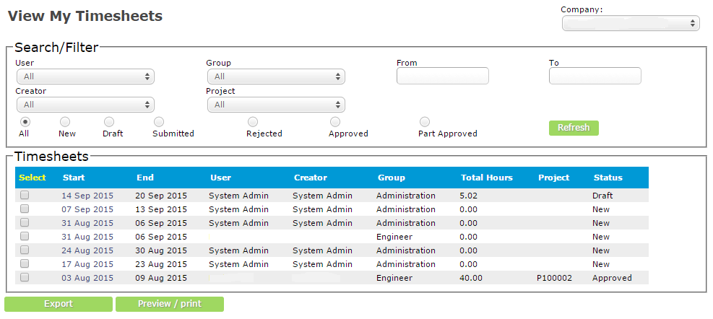
To aid in approvals and preparation for end of month tasks there are also some standard reports available, as follows:

Missing Timesheets
This report presents a list of all applicable users for the logged in user, by approval and team association, who are missing timesheets for the weeks in which the report is ran. The report can be exported to csv.

The data is pre-filtered to only show weeks for the user where they were an employee of the organisation, i.e.: based on the Join and Leave dates on the HR record.

The definition of “Missing” is if there is NO timesheet, the timesheet is not yet submitted or approved and can also be where approved but not all time fulfilled.
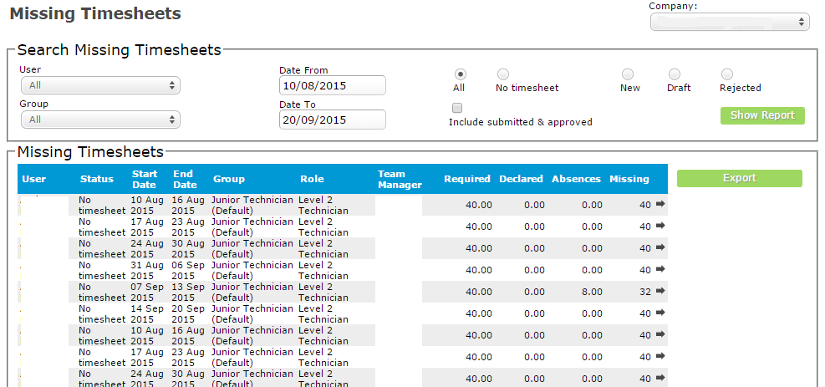

Time Analysis
From time to time an analysis of project time may be required – this is the report to do that. Its basic approach uses the filtered criteria to present all timesheets by user, project and analysis the total hours entered on timesheets. This is representative of ALL timesheets taking the filters into account of which are tailored to all and only the fields available on timesheets.
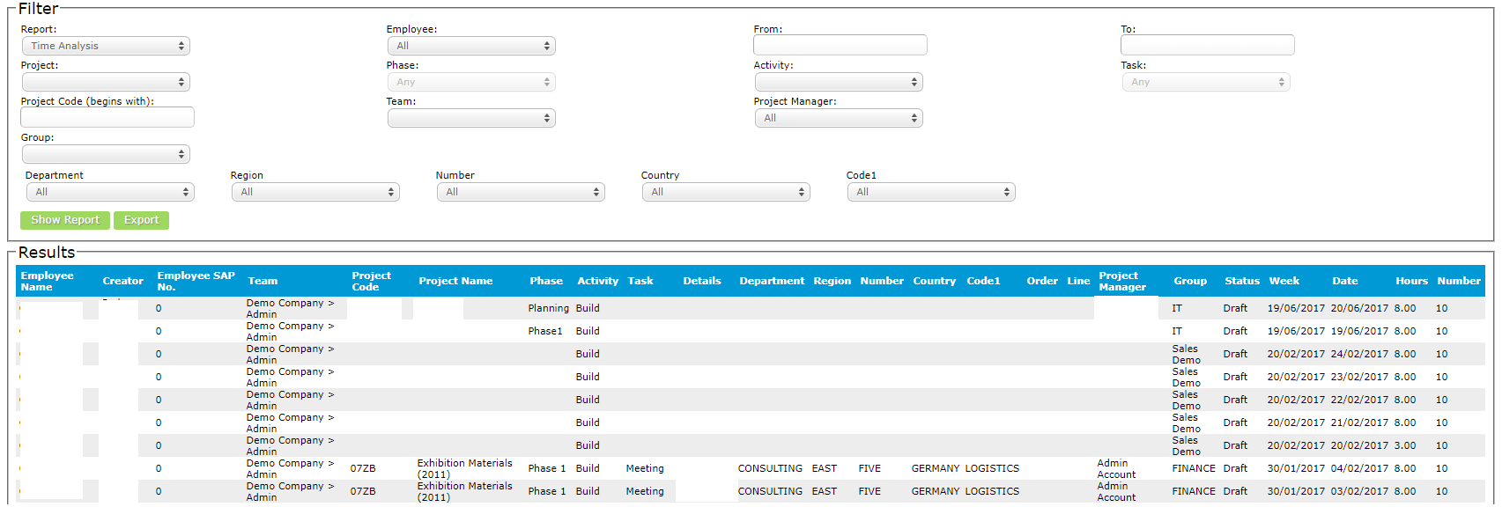

Time Spent
A summary of the time analysis report grouping by user and analysis the time spent in hours and based on settings, converted to days.
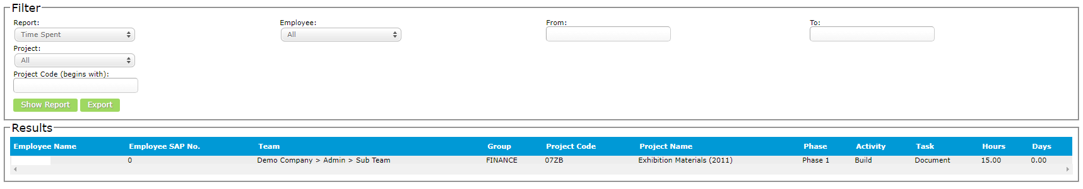

Status Summary
A display by user and week of the current status of timesheets (workis in addition to the missing timesheets report).
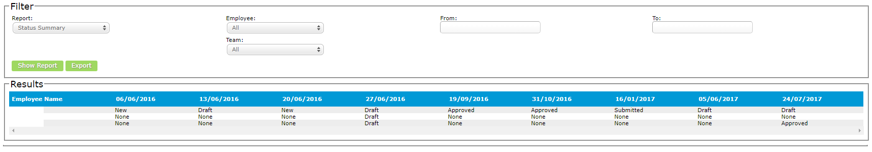

Time Costing
Depending on if using the project management and billing modules it is possible to calculate a cost breakdown by project, analysis, user and date versus a budget.
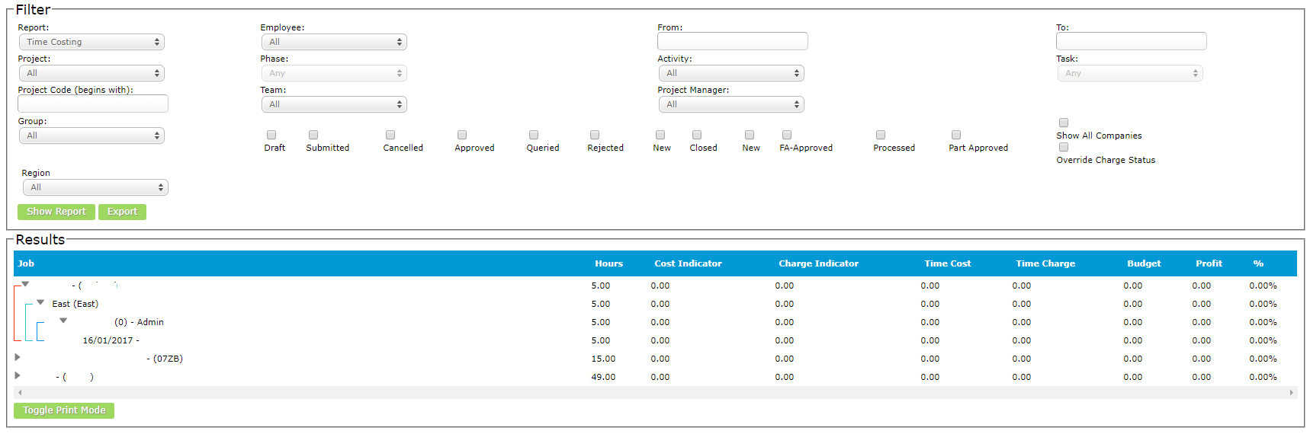

Month End
As mentioned above there is at times a requirement to submit a part week timesheet for approval. The month end facility allows for a date to be entered where timesheets can be submitted up to and NO dates after this can be entered until they are “opened for entry”.

Firstly, the date is set. Timesheets which are fully presentable can be fully entered and submitted but those where this date falls within the week will ONLY show the days up to and including this date. In doing so, the “Required Hours” for entry is taken into account and validation is manipulated.

Secondly, once these “split week” timesheets are approved the date can be extended. All timesheets which have days on that have been approved are reset to “Draft” but the days in which an approval has been made are locked for editing, as is the analysis on the line to ensure integrity. These days can then be used in billing and any document creation as described later in this document and the rest of the timesheet can be entered and submitted for approval under the normal logic.

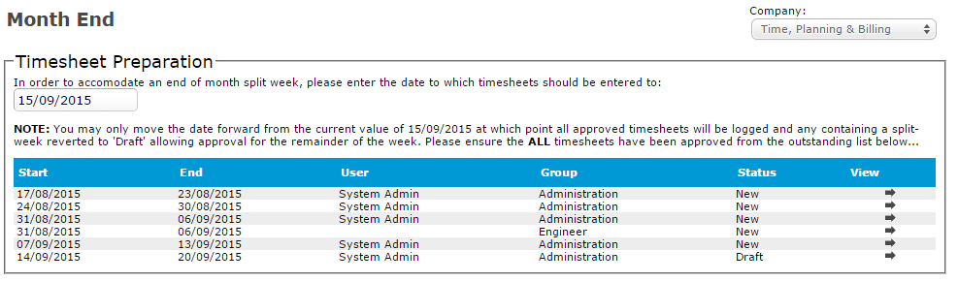

Journals
Once a timesheet is approved a journal can be sent to SAP. This journal can map any field captured on the timesheet line entry to a field in SAP, including UDFs.

There are two options for the postings and in both cases common lines will be grouped and summed together:
- Each day on each timesheet line is added to the journal as a credit and a duplicate line as the debit
OR
- Each day on each timesheet line is added to the journal as a credit with FULL analysis with a single line added to the debit with NO analysis but a total of ALL credit lines to balance the posting

