Getting started

Log In

Using your web browser go to your system web address. You will see a login screen like the one shown below.
Note: if iDocuments is set up for single sign-on you will bypass the login.

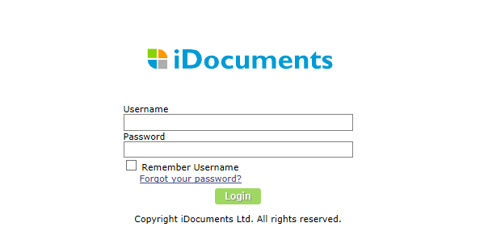

Your Home Page
After logging into iDocuments, users will see your Home page, which is configured to your user profile.
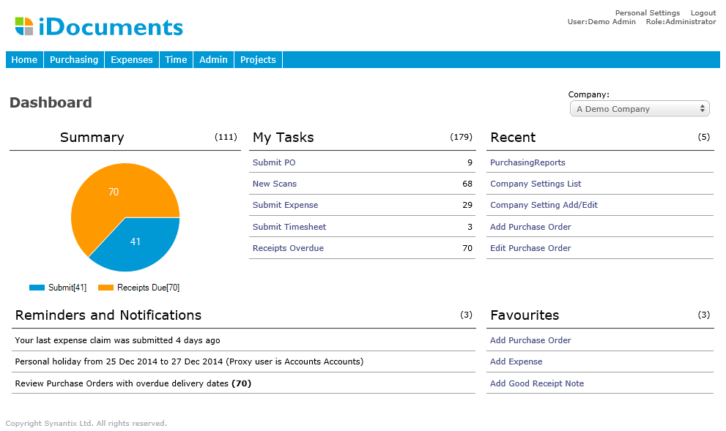

Company: Most Users will only work for one Company and that will be defaulted when they log in. If you have the option of Adding, Approving and Viewing documents for more than one Company, you will also have a default Company set up, but you will also be able to select the Company you want to work with from the drop-down list available. All documents and actions are Company-specific.

Recent: This panel lists your most recent actions as links.

My Tasks: This panel shows you a summary of personal actions in the form of links to a list for each type of action.

Favourites: You can set up short cuts to forms using the ‘Personal Settings’ function (see below).

Deadlines, reminders and notifications: Messages that are relevant to the User are posted in this panel.

Personal Settings

A ‘Personal Settings’ link at top of the form allows you to change your password and other items, which are specific to you. Click on ‘Personal Settings’ to access the Personal Settings menu.

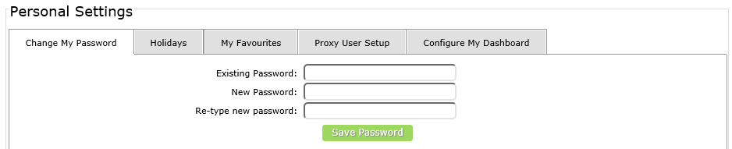
‘Change My Password’ - Type in the password fields to change your password.
Note: This function will not apply if iDocuments is set up for single sign-on.

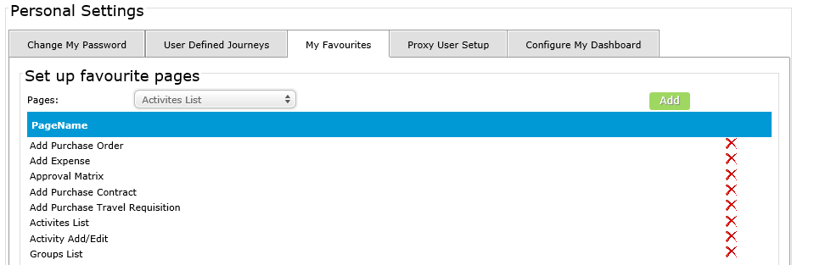
Select the actions you want to add to your ‘Favourites’ panel and ‘Add’ each one.

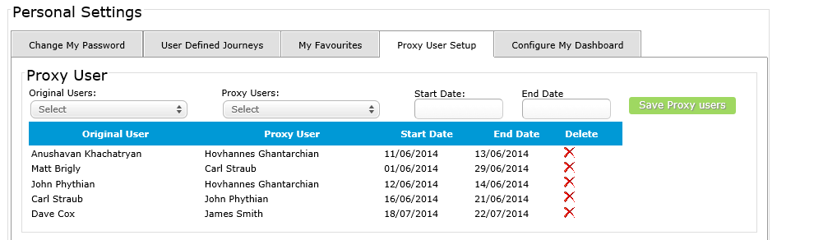
Select ‘Proxy User setup’ to assign another user to login as you by proxy. Select the original user, the proxy user you want to assign and the date range.

