User Guide
iDocuments Service Management

07 May 2019

Contents

1. Introduction 3
2. Other sources of information 3
3. Process overview 4
4. Dashboard 5
5. Service Dashboard 6
6. Dynamic Documents 7
7. Document management – procedural and guidance documents 7
8. New Service Request 8
9. Scheduling 12
10. Service Person fulfilment 22
11. Service desk completion 26
12. Workforce HR self-service 28
13. Workforce HR time-off and absence management 28
14. Smart View reports 29
15. Billing 30
16. Payroll integration 30

Introduction
iDocuments Service Management is a web browser and mobile based service management solution which helps to improve efficiency, productivity, control and compliance.

Service requests can be scheduled, i.e. recurring requests based on a Service Agreement or they can be reactive, in response to a specific unscheduled issue.

iDocuments Service Management automates management of the following service process; service request, scheduling, tracking, delivery, follow-up, reporting and analysis.

- Service Desk: Centralized management of field service fulfilment
- Service personnel Mobile app: Assignments, service completion and documentation and service notes.

Users access is profiled according to their role and the data they need, so for example, users may only see the data for the Agreements they are managing.

Other sources of information
Further information is available at www.idocuments.co.uk and https://www.idocuments.co.uk/technical

Process overview
iDocuments Service Management incorporates the following processes:
- Customer service requests
- Service agreements
- Scheduling
- Workforce HR details, skills and attributes
- Automatic alerts and reminders
- Dynamic Documents – configurable documents, checklists and workflows
- Document Management – procedural and guidance documents
- Time tracking
- Reporting
- Billing – ERP integration
- Payroll export

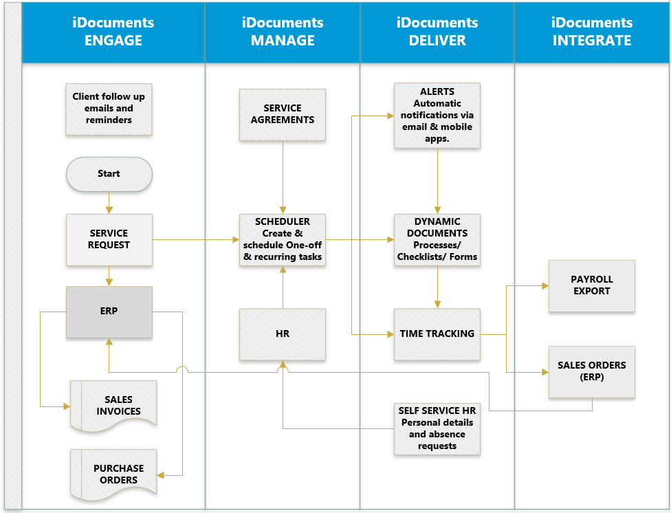

Dashboard
The Dashboard will provide the user with a Summary of their Tasks and Alerts and quick access to the forms they use most commonly.

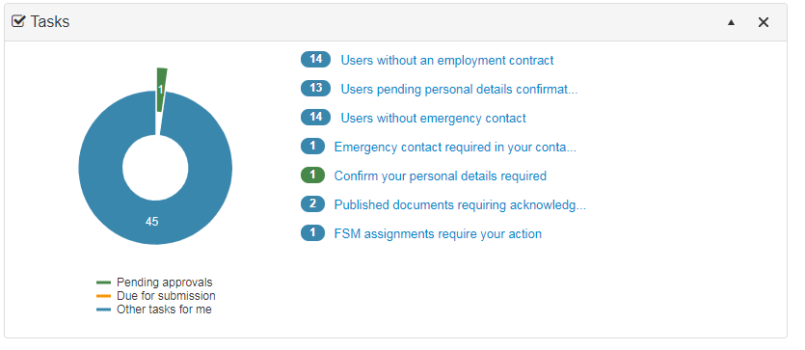

Tasks
Lists Tasks assigned to you; click on the task link to action.

If you have any FSM assignments require your action tasks, clicking the link will take you to the Service Dashboard.

Quick Access
For each user, quick access will present links to the forms most commonly used.
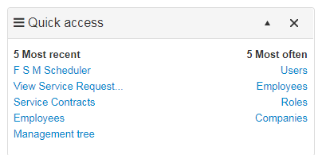

Service Dashboard
User Dashboard > Services
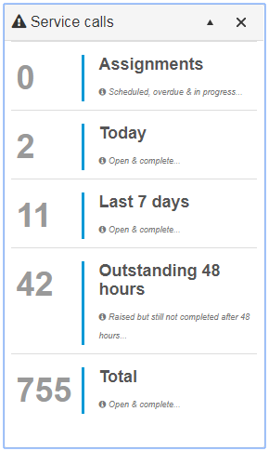
Service Calls
- Assignments allocated to the Service Person logged in.
- Today – tasks outstanding.
- Last 7 Days – tasks outstanding.
- Outstanding 48 hours – tasks outstanding.
- Total – all current Service Requests
Agreements
- Displays a list of Agreement related tasks
Service Requests raised
- List of Service Requests raised for the current ‘Service Call’ selection, colour coded by status.
SLA Triggers
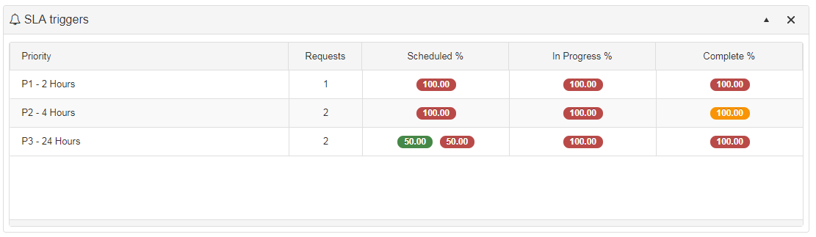

- Overview of Service Requests status by SLA Priority target with ‘traffic light’ alerts.

Dynamic Documents
Dynamic Documents is powerful and flexible facility that allows you to create workflows, task lists and custom processes.

iDocuments offers you the facility to create user-defined documents that work dynamically with iDocuments and your ERP data, giving you the flexibility to define the fields, rules and workflows you need. Dynamic Documents puts the user at the centre of the process, where document permissions and approvals are linked to a user’s profile.

See iDocuments Dynamic Documents User Guide for details.

Document management – procedural and guidance documents
iDocuments integrated Document Management facility allows you to distribute and manage procedural and guidance documents and ensure Service Persons and other staff are accessing the current and up to date versions of documents, diagrams, photographs, spreadsheets and drawings.
A library of documents is maintained which can include Microsoft Word, Visio, PowerPoint and Excel documents with version control. Service Persons are given access to this this library of information using easy to use search and drill-down facilities.

New Service Request
The following Dashboard screen shows the typical functions available under the Service menu. Individual users’ menu items will be determined by their profile setup.

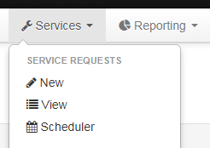

From the Services main menu, select Service Requests > New.
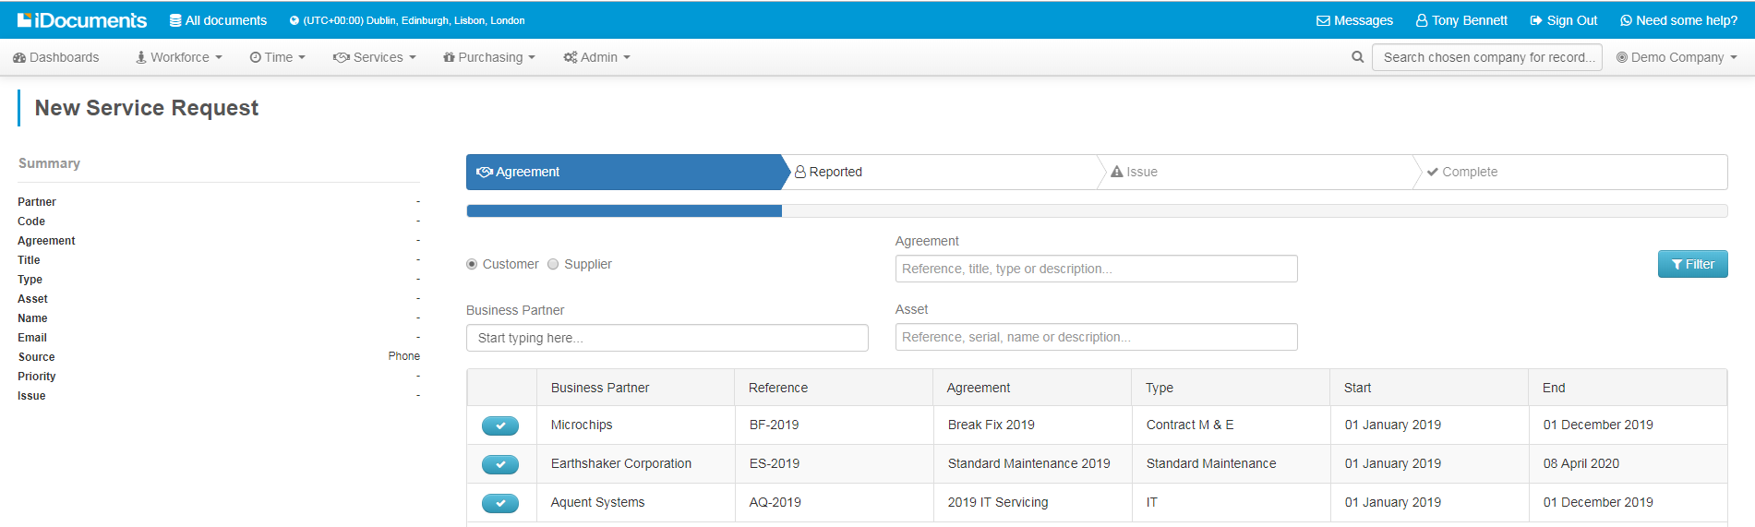

Agreement form
- Select Customer
- Business Partner – Enter details you have from the incoming Service Request. If you know the name of the business partner, start typing in Business Partner field and the predictive field will present you with the name. Add any details of the Agreement type and Asset, such as reference number.
- Agreement – the system will present a list of active agreements filtered by the information entered in the partner fields. Click to select the Agreement you wish to raise the request for and advance to the Reported form.

Reported form
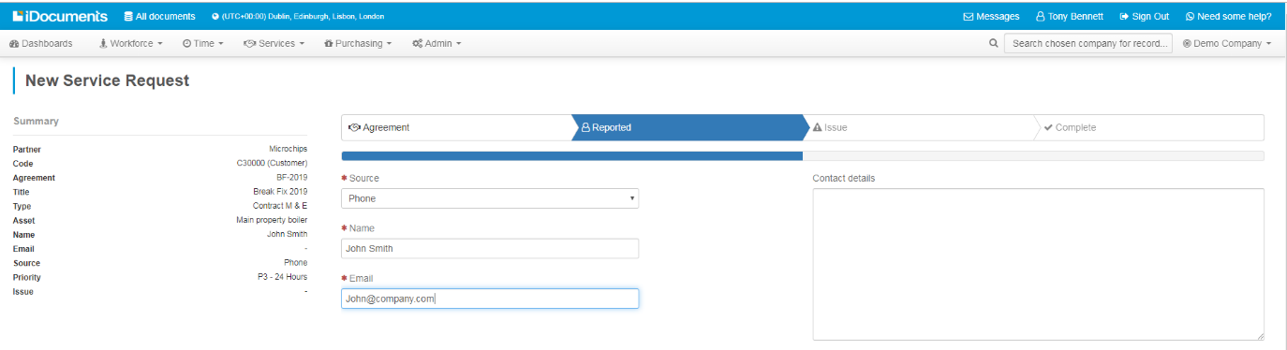
To the left of the screen, the form will display a summary of the Agreement you selected.

Complete the fields as necessary, as fields are completed, they will populate the summary: select the Source and complete the Name and Email fields. Automatic alerts for the service will be sent to the contact details shown here if they have been set up in your system. Once these fields are populated you can advance to the Issue form.

Issue form
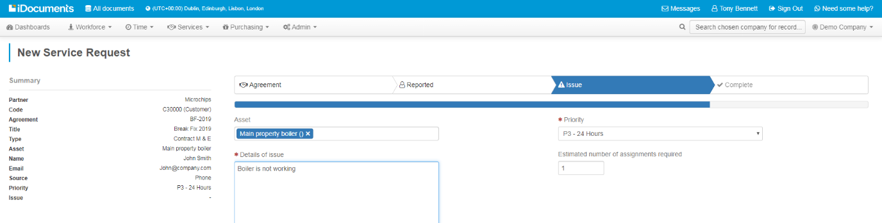

- Enter Details of issue and any special instructions for the Service Person.
- The Priority will default to the Service Agreement, this in turn triggers the SLA. If applicable the priority can be manually selected at this point.
- Enter the Estimated number of assignments required. If known, the service desk can enter the number of Service Persons required to complete the Service Request. The system defaults to 1.
- Assets – if Assets have been setup for the Agreement selected, type in the Asset field and you will see a drop-down of related Assets that may be selected. It is possible to select multiple Assets if required. If the Asset is not known at this point it may be added at a later date. If only one Asset is set up for an Agreement it will auto-populate the issue form from the Agreement data.
- If an Asset requires Readings, if applicable, you can also enter a Current Reading if known.

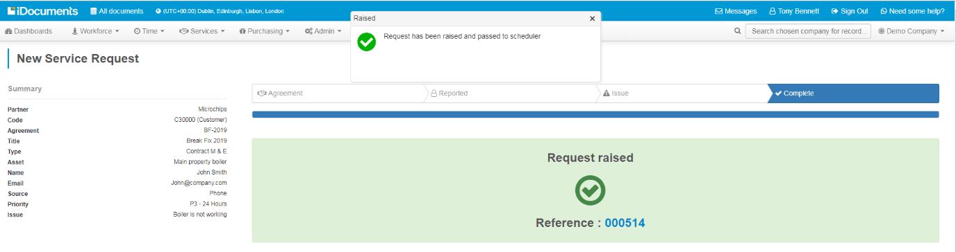
- Raise the request once all the details have been entered. A Request Raised confirmation will assign a unique Reference number for the request. An automated email alert will be sent to the customer contact as shown on the Contact form.
- Service Requests > View displays the View Service Requests dashboard. Your request will be listed and may be selected for review and edit.

Scheduling
If your Service Request requires scheduling, from the Services main menu, select
Service Requests > Scheduler. Service Requests can be either recurring requests which may be scheduled in advance on a recurring basis, or call-out requests, that are scheduled as they are received.
Service Request Summary
Diary Views
Service Requests List
Filter Users Icon

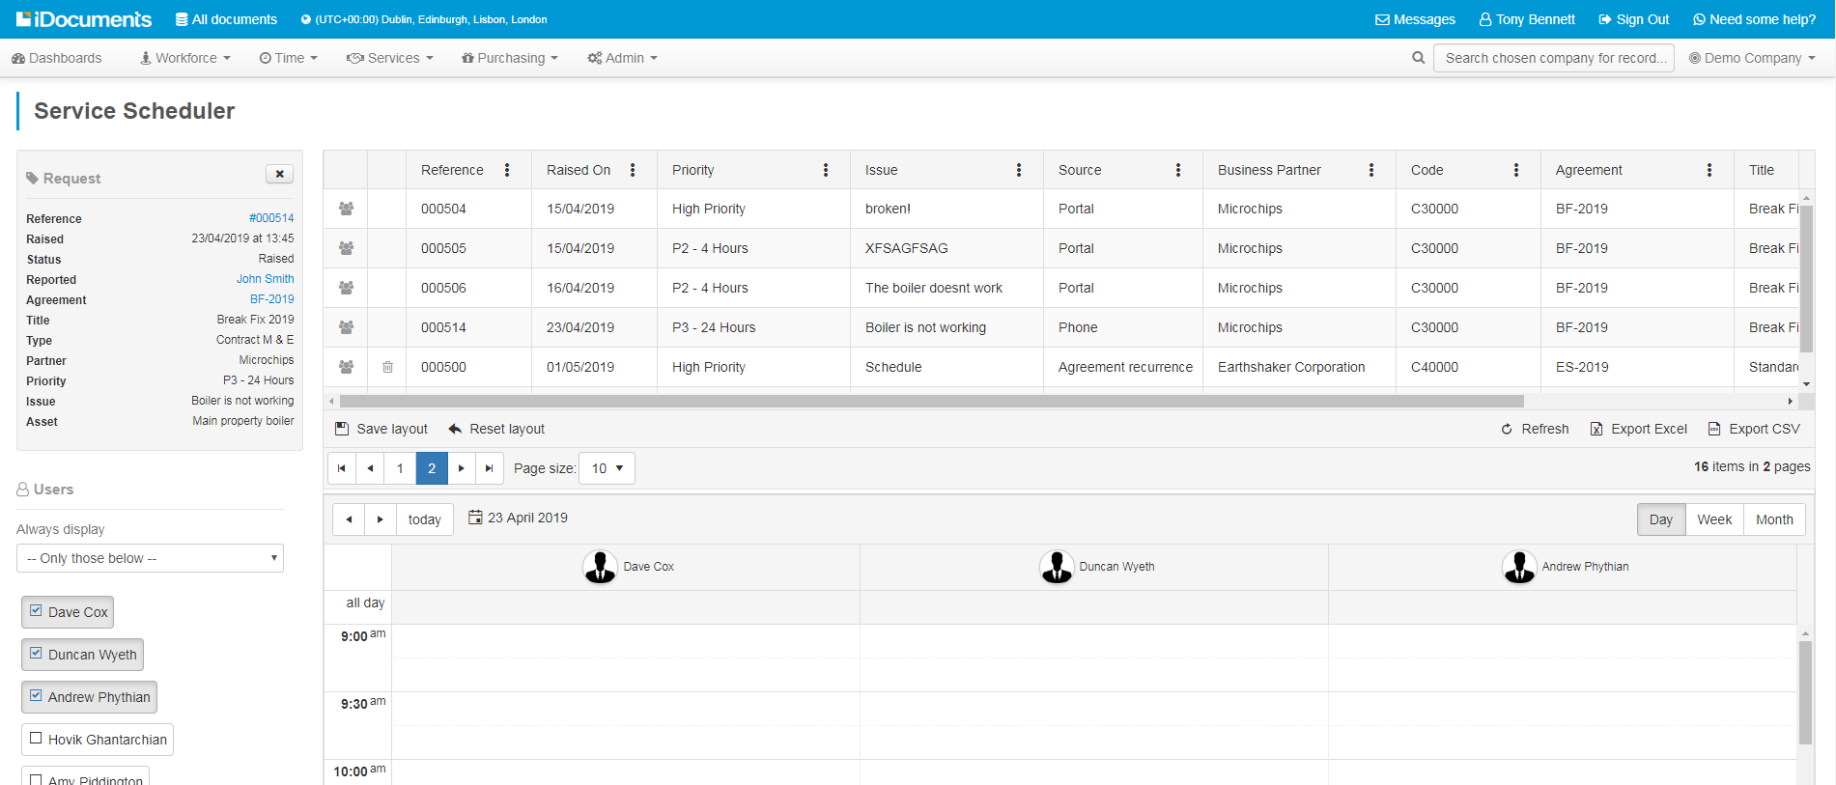
Request Source
Filtered Service Persons
Filter List

Scheduling Diary Functions
- Service Requests: A list of Service Requests to be scheduled is shown above the diary.
- Service Request Source: The list will show if a request is part of a scheduled agreement, Agreement recurrence; which may be scheduled to recur in advance for a defined duration, a reactive call-our request, such as a phone, email or website; or a follow-up to an existing Request.
- Filter Users – to show the summary of the request and prompt the most suitable service personnel, based on location and definitions for the request. Service Personnel must be configured for a Location before they can appear on the selection list.
- Filter List: Service Persons, Locations and Definitions will be automatically filtered by agreement and asset configuration or can be manually filtered so the diary will only display Service Person(s) that satisfy the Service Person, Locations and Definitions criteria selected. Items on the list may be selected or deselected to present the user with available Service Persons that satisfy the selection criteria.
- Service Persons: Service Persons are shown in the scheduler for filtering and selecting as required. The list shown for a particular Service Request selected is defined by those personnel set up for the Service Type associated with the Request that are also defined for the Service Desk User who is logged in. Selected Service Persons are shown in the diary for ‘drag & drop’ scheduling.
- Views: The Diary presents a choice of Day, Week, Month, Timeline views.
- Schedule block: The time period for the request is defaulted to what is defined in the Service Agreement configuration for the Asset Type scheduled. The default is an estimated time but may be edited by the Service Desk as required.
- SLA Colour Coding: SLA’s will be colour coded according to your Company setup.
- Time Units: Time is scheduled in units of half hour, with half hour being the minimum permissible for scheduling and one hour the default.
- Quick View – Right click on the scheduled job and Quick View to view the Request summary on the form.
- Results – Right click on the scheduled job and Results to open the the job sheet.
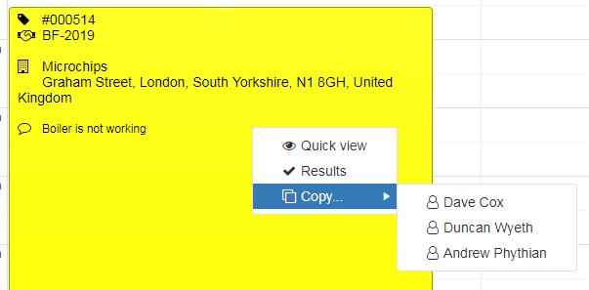
- Copy – copies a job to another Service Person selected from the available list and automatically places the copy in the diary for the selected Service Person for the same date and time.

Navigating the Request list
Search: If you know the request reference You can use the search field at the top of the form to access the Request form.

Filter: Each of the columns offers a choice of filters appropriate to the column content.
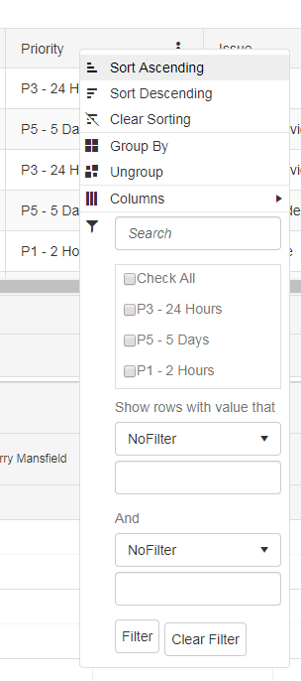
Scheduler Views and Export
- Advance arrows – use the arrows to file through pages
- Page size – select the number of records viewed from the drop-down list
- Day, week, Month – toggle view
- Date – click arrows to advance/return by day or click on the Date to view the diary for date selection.
- Save Layout – saves your form format i.e. filter selection, including position and visibility of columns so that when the screen is refreshed only the data is affected.
- Reset Layout – clears your filter selection and returns to default view
- Refresh – refreshes the from after filter selection so that only the data is updated
- Export Excel – exports your filter selection as an Excel file
- Export CSV - exports your filter selection a CSV file
Selecting a Service Person
You will see a list of service requests at the top of the diary. If you click on the Service Person icon you will see a Service Request summary panel.
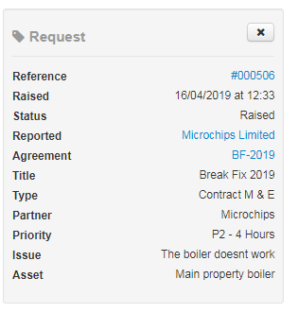

If the request has an associated Agreement and Assets, select a request by clicking the Service Person icon, the system will default the Service Persons based on the requirements for the job, business partner Location and and Definitions i.e. skills criteria associated with the Agreement and Asset setup.

Note: You may also manually select specific Locations and Definitions items to filter the Service Persons that satisfy your selection.

Scheduling the Diary – call-out Requests
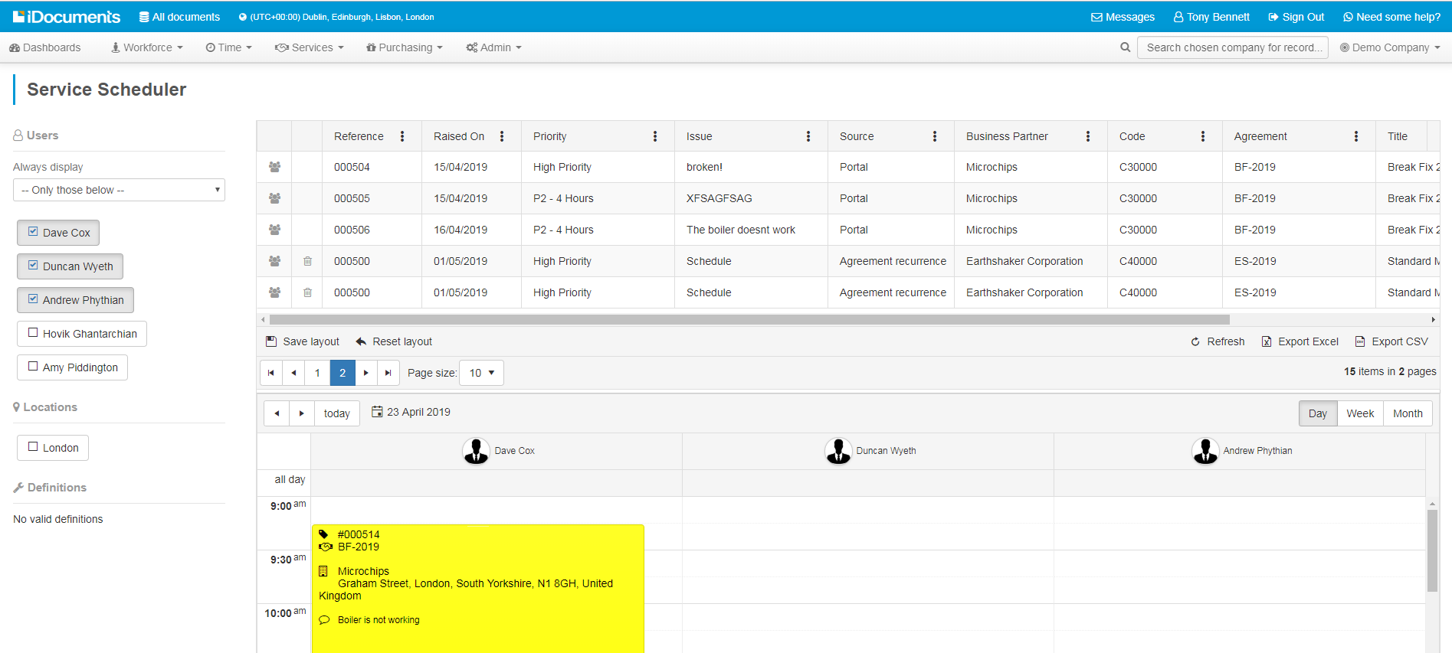
Once you have you filtered list of suitable Service Persons, from the request, and selected the location you can drag & drop the request onto the diary under your selected Service Person at the time you want to schedule them.

Once the Service Request is scheduled in the diary is removed from the schedule list and display as a block, colour coded by Priority, showing Service Request number, Agreement number, business partner and Service Request description.

A Service Request block may be moved to a different time, day or Service Person by dragging the job and moving it to a new slot.

The system will automatically validate a Service Person when you drag a Service Request into their diary.

If the Service Person you have selected does not satisfy the criteria for the Service Request then there will be a validation warning message. You may wish to go ahead with the schedule the system will allow you, unless the validation is a mandatory requirement.

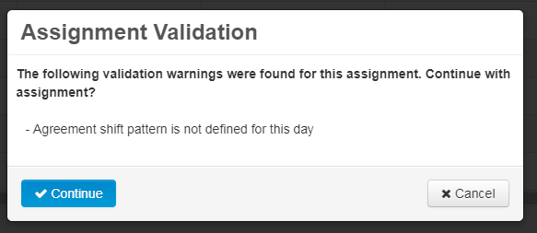

You can drag a Service Request to a new date, time or Service Person. If the Service Person you move it to does not have all the requisite skills and definitions defined for the request, then you will see a validation warning as you move the job. Copied jobs may be deleted by clicking the ‘x’ box.

Once a Service Person has commenced a request it becomes read-only and cannot be moved.

Scheduling the Diary – Agreement Service Scheduling
You can schedule recurring agreement service requests for the occurrences for the duration of the agreement: from the Services menu select Agreements then View to see the Agreement list.

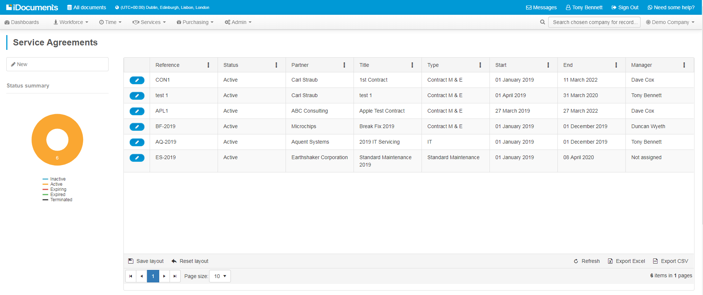

Select an Agreement that is status ‘Not Assigned’ and the Agreement form will contain a ‘Scheduling Required’ alert. Scheduling could be required either for the entire agreement of for a specific Asset. All scheduling details need to be completed before the system can schedule a recurring task.
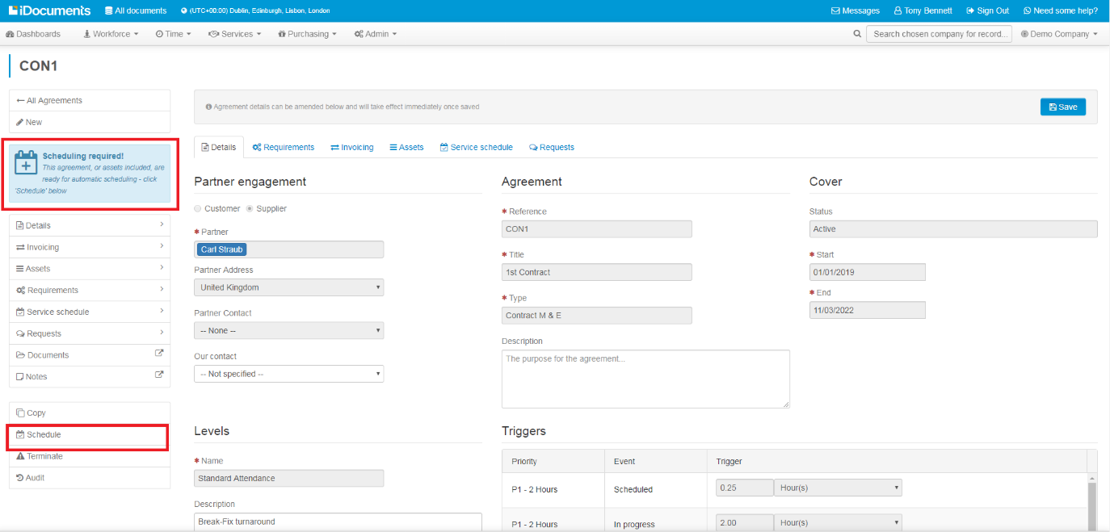

To schedule a recurring request, click the Schedule button. You will see an alert asking you if you are sure you want to schedule the agreement as you can only schedule once.
You will be presented with a start from pop-up. Select the date you want to start the batch scheduling from. The date will default to the contract start date but this may be edited. Once the date is selected click OK.

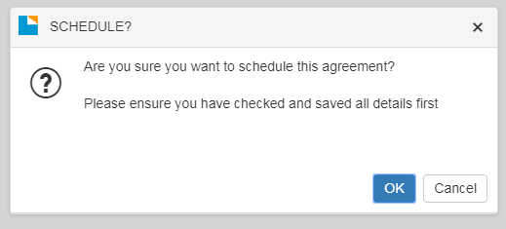

The Agreement will be auto-scheduled from the date you select.
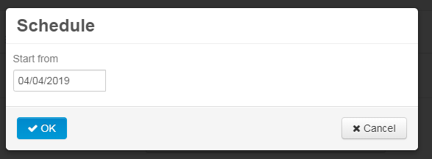
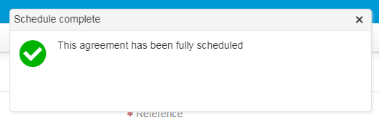

If you select the Service Schedule tab, you will see details for the scheduled Requests.
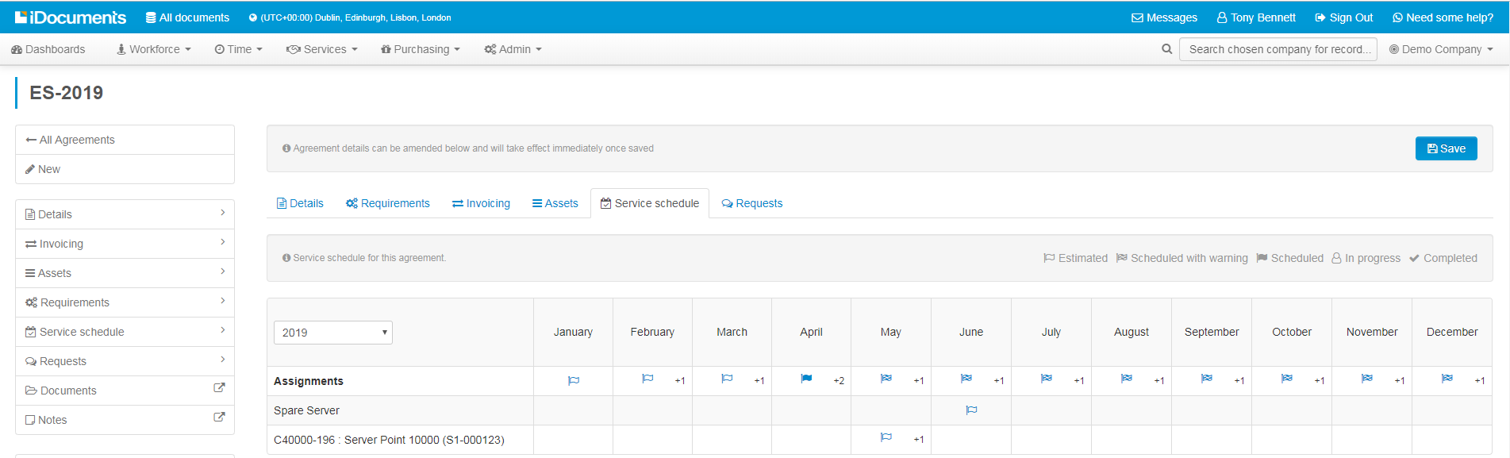

There will be a line for Assignments for the Agreement, which displays the schedule details (if applicable) and also a row for each of any Assets assigned. You can select a month from the drop-down diary to view the Requests for the given month. Click on the Request to drill-down to the Request details.

Scheduling the Diary – Asset Scheduling
The Services > Register allows you to view Assets created for a customer. Asset scheduling – runs from the Asset start date to the end of the contract/termination date.

To schedule an Asset from the Scheduler and select the Asset to schedule.

From the Request form, filter the Service Person, Location and any requirements as you would a call-out service request and drag & drop the Request onto the dairy.

As this is a Batch request, you will be presented with a pop-up whereby you can determine what period is to be batch scheduled.
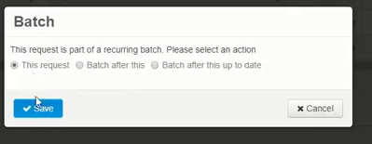

You have the option of scheduling the next occurrence, batch scheduling all occurrences for the duration of the agreement, or batch scheduling all occurrences up to a defined end date. Once you Save, you will see all occurrences scheduled in the diary for the Service Person you selected.

Once in the diary, it is possible to move all scheduled occurrences of a batch Request to a different day/time or Service Person, rather than having to move each one in turn.

Schedule Warnings
The system will display automatic warnings in the schedular view for the period viewed, to indicate there is a scheduled block that has an alert. Typically, these are jobs scheduled where there is a verification alert such as if the Service Person does not have one or more of the skills or definitions, is in the wrong location or if the Request is double-booked, clashes with another Request or is out of working hours defined for the Service Person selected. The warning will also flag up if the Service Person has a planned holiday booked for the period you wish to schedule.

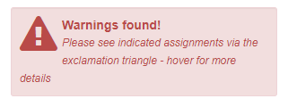
If there is a warning relating to a block then it will display as a warning triangle in the block.
From any of the diary views, if you hover the cursor over a block, any alerts will pop-out.

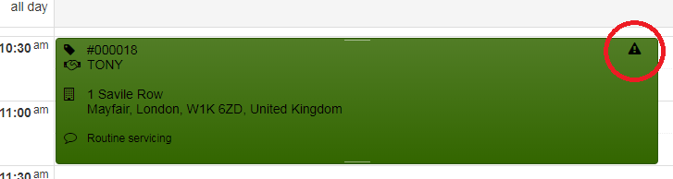

Service Person fulfilment
Select Service Request > View for a list of current service requests.
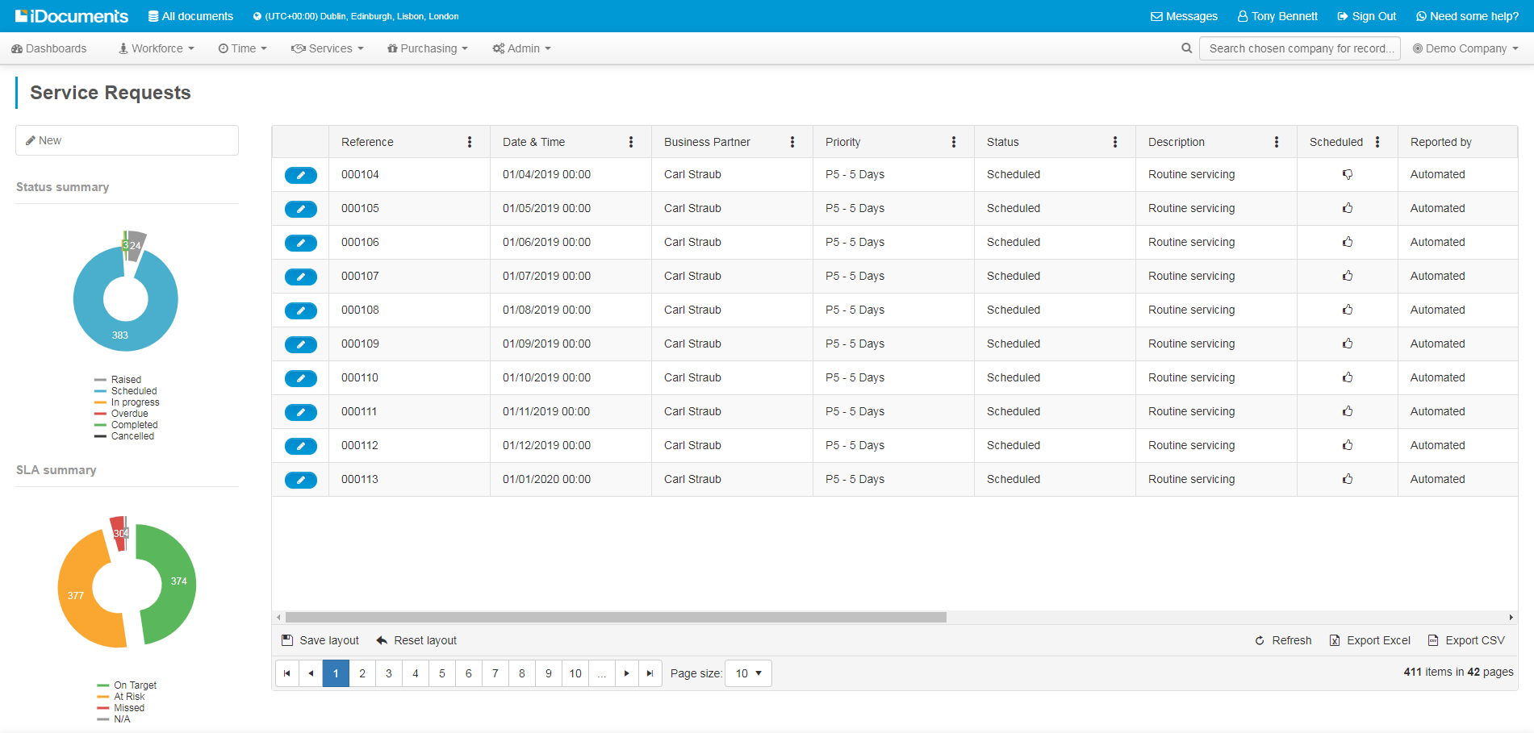
Select the service request from the list to view details:
- Request details
- Asset details
- Agreement details
- Request status

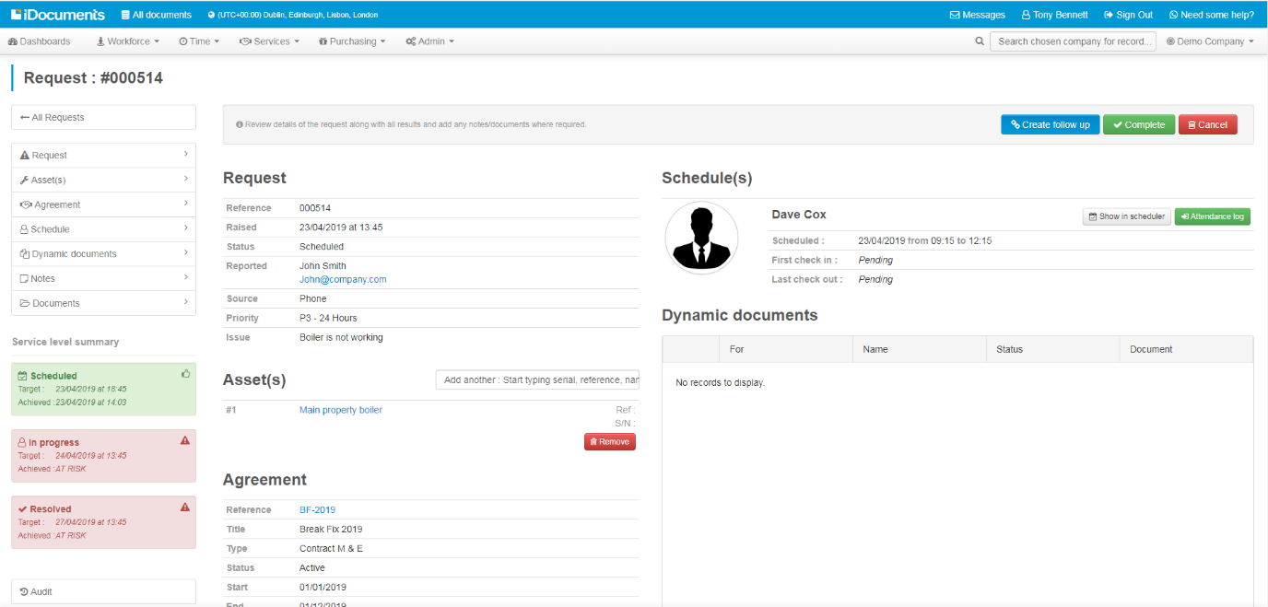

Attendance Log
To record commencement of a Service Request, click the Attendance Log button to specify start time for Travelling or Working.

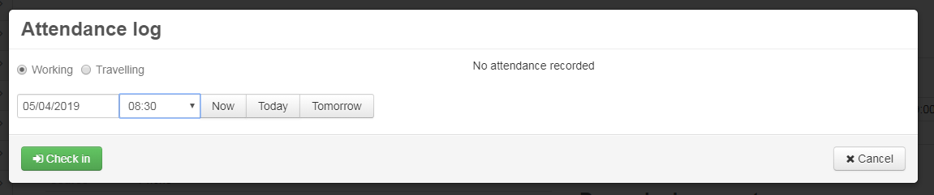
Enter the start date and time and Check in. The check in time on the Service Request for the activity specified is logged. The status of the Service Request will change to In Progress.

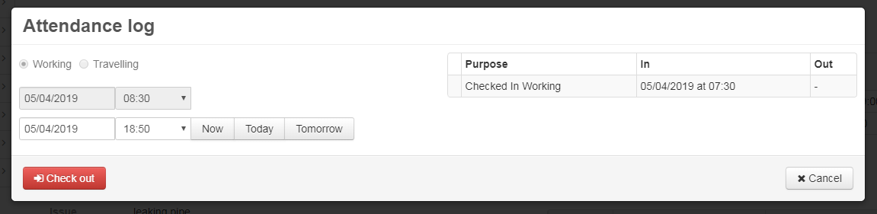
When the activity is completed enter the end date and time and Check out.

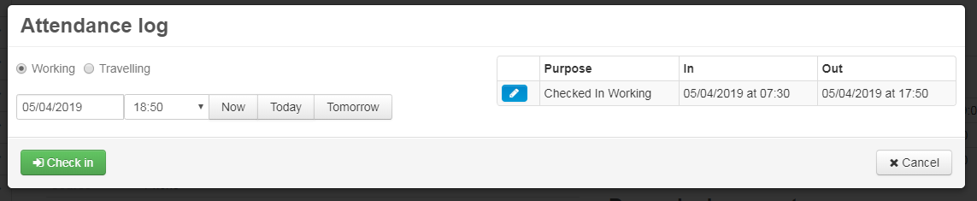
Attendance log will record check-in and check-out times. Once the Service Person has completed the scheduled attendance, the status of the request will change to Resolved.

Readings
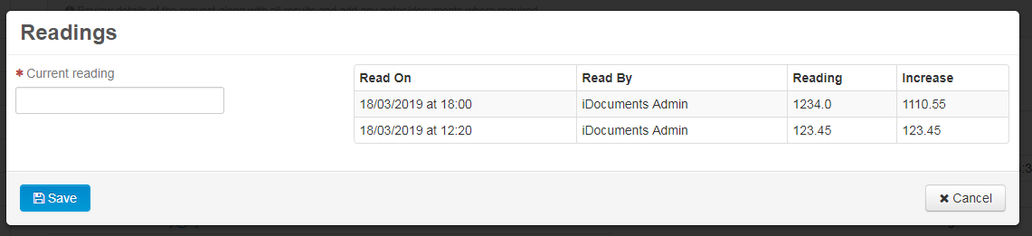

Notes
Notes may be added to the Service Request at any point in the process. The system logs the user and the date/time the note was added.

Documents
Documents and photos may be added to the Service Request at any point in the process. The system logs the user and the date/time the note was added.

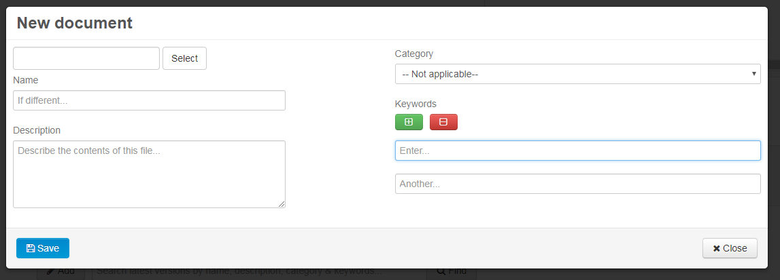

Dynamic Documents
If there are any mandatory documents that are applicable, they will be listed for the Service Request in the Dynamic Documents panel as requiring completion. The Service Person can open the document and complete the fields presented as part of the service delivery, add any notes or associated documents or photos then Save or Submit. Documents are validated and recorded as complete. All mandatory documents must be completed before the Service Request can be Completed.

If there is an associated workflow the document will feed into the workflow.

The Service Request will show the status of the document. Once the workflow is completed and the document approved as required the document will show status Approved.

Service desk completion
Service Request Completion
The service desk can open the Service Request for review. At this point the Service Request can still be edited, notes and documents added if required.

Validation: a service request can only be completed if the Service Person has checked out and has no outstanding dynamic documents that require mandatory completion.

Once everything is in place click the Complete button. The system shows the Service Request has moved to a status of Completed.

Create follow up
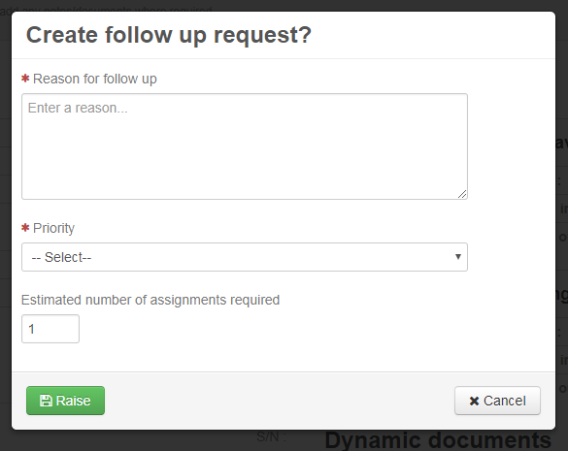

Service Request Follow-Up
If there is a requirement for a follow up action click the Create follow up button. Enter the Reason for follow up, select a Priority and Estimated number of assignments required and Raise. The system will automatically create a Request with the Source indicated as Follow up, along with the reference to the original request.

Audit
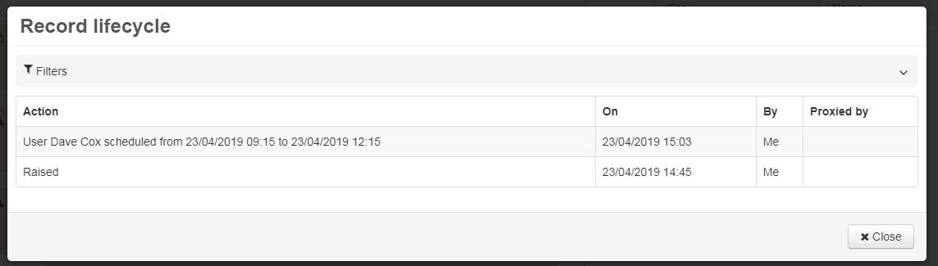Within the Service Request select Audit for a detailed record lifecycle history for the request.

Workforce HR self-service
iDocuments Workforce HR provides a staff self-service facility and providing the following functions:
- Personal details – with self-service and approval
- Absence management – holidays (with balances) and sickness
- Identification documents (managed by Dynamic Documents)
- Appraisals (managed by business processes in conjunction with dynamic documents)
- Equipment (managed by dynamic documents)
- Pay rates & benefits – list with type, frequency, value and currency
- Skills/Work Types/Qualifications – list with type, activated date and expiry date
- Locations – list with location, available from date and available to date (optional)
- Notes – list with note, date and user
- Attachments – list with type, key words, file, title, description and version history

Workforce HR time-off and absence management
Absence can be monitored as follows:

- Public Leave - non-working days, where allowance is not deducted
- Personal Leave (Holiday) - where allowance is deducted (e.g. holiday, vacation)
- Personal Leave – where allowance is not deducted (e.g. Doctor or Dental appointment)
- Sickness - where allowance is not deducted
- Compulsory Days – for Company closures, for example, between Xmas and New Year where allowance is deducted from all employees

Public holidays are automated from the assigned working pattern. All other absence follows the same structure, whereby the user may request the time of absence by submitting for approval to either line manager or HR.

The Time-Off module integrates into the scheduling and time tracking functions by feeding the information automatically to them. For example, holidays are shown on the timesheet to reduce the total number of hours for declaration.

Smart View reports
iDocuments Smart View allows users to quickly and easily create key performance and analytical reports such as those listed below. Smart Views allows users to filter data and export the results to Microsoft Excel spreadsheet.

- Service calls received to date
- Service calls completed
- Service calls outstanding
- Service calls outstanding more than 48 hours
- Cleaning audits not completed within last month
- Security audits not completed within last month
- Risk assessment out of date
- Staff skills/qualifications/toolbox talks out of date
- PAT test out of date
- Vehicle inspections not completed within past month
- Agreement renewals

Billing
Seamless ERP integration automatically creates sales orders and invoices for reactive work generated by Service Requests or recurring maintenance billing.

Payroll integration
iDocuments payroll export function allows export of hours and hourly rate per site for each worker for standard or overtime hours. Once exported, a transaction is marked with exported status. The report which produces this export will export only transactions that have been marked as not exported.

