Purchasing

Introduction
iDocuments Purchasing is a web browser based purchase to pay solution which helps to improve efficiency, productivity, control and compliance.

iDocuments manages the entire purchasing process, streamlining and automating the process of requisitioning, ordering goods and services, contracts, receipting and matching invoices to orders and receipts.

Creating a Purchase Requisition
The following Dashboard screen shows the typical functions available under the Purchasing menu. Individual users’ menu items will be determined by their profile setup.

From the Purchasing main menu, select Add Purchase Requisition.
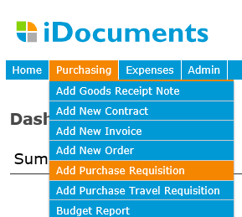

First complete the Requisition Header; typically the following fields:
- Supplier – at this stage you may not know the supplier, in this case, this field may be left for selection further down the approval workflow. If you do know the supplier this can be selected from the drop-down list of active customers taken from your Accounts or ERP system.
- Order Type – SERVICE or ITEM (this may default depending on your system setup)
- Group – if a User is enabled for one department; that will be defaulted.
- Required Date - (as standard this is defaulted to current date).

The following fields will always default:
- Supplier address – this is pulled from the Accounts or ERP system Supplier record if the supplier is selected.
- Currency field – this is the currency set up for the Supplier in the Accounts or ERP system and will default if the supplier is selected.
- Creator – defaults to the user entering the order
- Approver – this field is for display only and shows the requisition approval workflow for the Group selected.

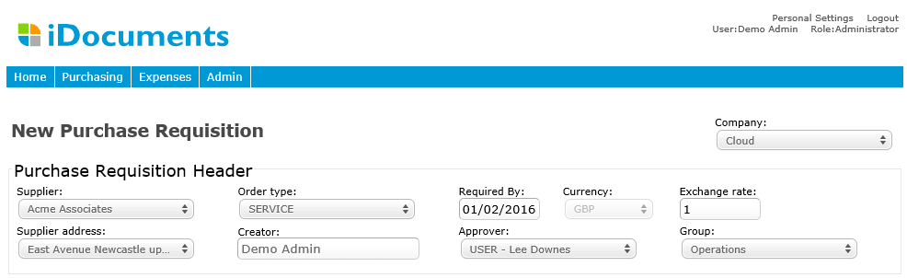

Creating a Purchase Requisition
The following Dashboard screen shows the typical functions available under the Purchasing menu. Your individual menu items will be determined by your profile setup.

Adding Purchase Requisition Lines – SERVICE Type Requisitions
To add a purchase requisition line, you can optionally select the GL Account from the drop down box of GL Accounts available (The accounts available to you are determined by your Group configuration). If you don’t know the GL Account at this stage, it can be selected by an Approver further down the workflow. Type in the line Description and optionally, any Free Text. Optionally, type in the Unit Price (if known) and Quantity.

Adding Purchase Requisition Lines – ITEM Type Requisitions
To add a purchase requisition line, you can optionally select the Item from the drop down box of items available (The Items available to you are determined by your Group configuration). If you don’t know the item at this stage, it can be selected by an Approver further down the workflow. Type in the line Description and optionally, any Free Text. Optionally, type in the Unit Price (if known) and Quantity.

You may, optionally, have analysis codes available on the line, these are specific to your company setup. If these are shown, select from the drop-down box for each. If only one drop-down option is available for a Group, it will be automatically selected as the default.

Click the + button (marked with the red box) to add further lines if required and click the Submit button when you are done.
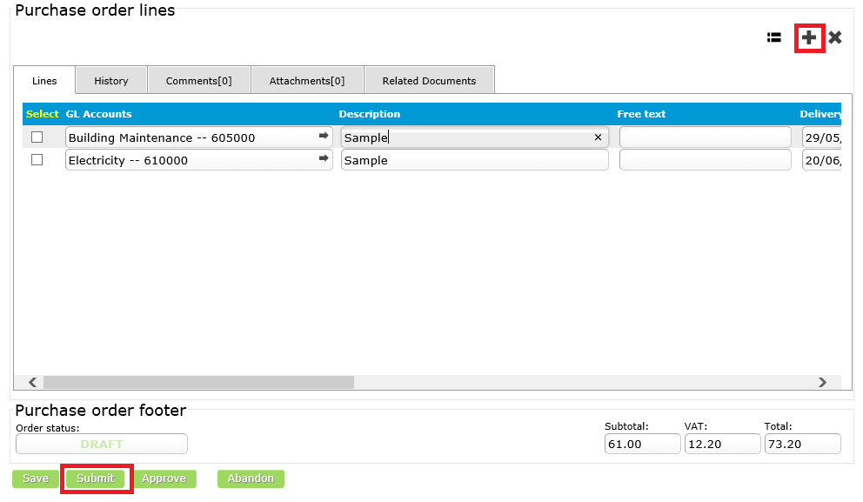

From the Purchasing menu > View Purchase Requisitions, the Purchase Requisition List screen will show your requisition as Submitted; at this stage it will be assigned an iDocuments system generated reference number.

When you Submit a purchase requisition, an email will be send to the next approver in the workflow informing them there is a new purchase requisition for Approval: your purchase requisition is routed through the workflows set up by your Group. Once a purchase requisition is fully approved it will be available for selection and conversion to a purchase order.

Creating a Purchase Order
The following Dashboard screen shows the typical functions available under the Purchasing menu. Your individual menu items will be determined by your profile setup.

From the Purchasing main menu, select Add Purchase Order.
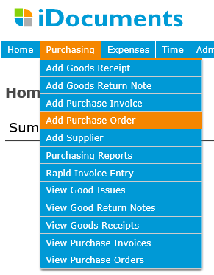

First complete the Purchase Header; typically the following fields:
- Supplier – select from the drop-down list of active customers taken from your Accounts or ERP system
- Order Type – SERVICE or ITEM (this may default depending on your system setup)
- Group – if a User is enabled for one department; that will be defaulted.
- Order Date – as standard will default to current date, Tax Date (optional, as standard will default to current date), and Delivery Date (optional, as standard will default to current date +30 days)
- Delivery To address – if there is more than one option available to select from.
- Bill To address – if there is more than one option available to select from.
- Description – a free text field.

The following fields will always default:
- Supplier address – this is pulled from the Accounts or ERP system record.
- Currency field – this is the currency set up for the Supplier in the Accounts or ERP system and will default when the supplier is selected.
- Creator – defaults to the user entering the order
- Approver – this field is for display only and shows the purchasing approval workflow for the Group selected.

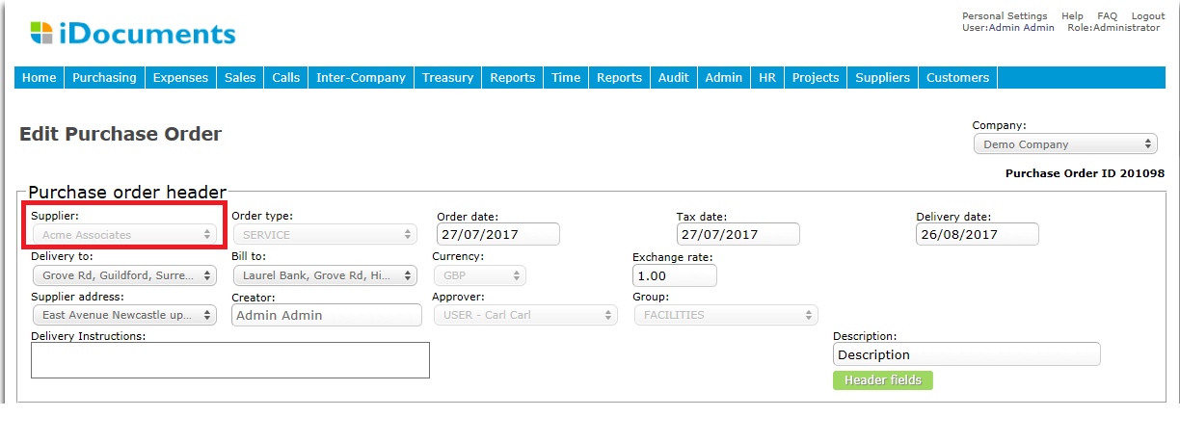

Adding Purchase Order Lines – SERVICE Type Orders
To a Purchase Order line, select the GL Account from the drop down box of GL Accounts available (The Accounts available you are determined by your Group configuration). Type in the line Description and optionally, any Free Text. Type in the Unit Price and Quantity - the line total is then calculated.

Adding Purchase Order Lines – ITEM Type Orders
To add a purchase order line, select the Item from the drop down box of items available (The Items available to you are determined by your Group configuration). Type in the line Description and optionally, any Free Text. Optionally, type in the Unit Price (if known) and Quantity.

You may, optionally, have analysis codes available on the line, these are specific to your company setup. If these are shown, select from the drop-down box for each. If only one drop-down option is available for a Group, it will be automatically selected as the default.

Click the + button (marked with the red box) to add further lines if required and click the Submit button when you are done.

From the Purchasing menu > View Purchase Orders, the Purchase Order List screen will show your order as Submitted; at this stage it will be assigned an iDocuments system generated reference number.

When you Submit a purchase order, an email will be sent to the next approver in the workflow informing them there is a new purchase order for Approval: your purchase order is routed through the workflows set up by your Group. Once a purchase order is fully approved and posted to your Accounting or ERP system, your order will be updated with the PO number.

Purchase orders may be printed or emailed to suppliers after approval.

Purchase Order status

The following describes the status of a Purchase Order:

Draft = A Purchase Order created by the Originator but not yet Submitted
Submitted = A Purchase Order Submitted by the Originator for Approval
Part Approved = Approved by one or more Approvers but with further Approvals required in the workflow.
Approved = Fully Approved by all Approvers in the workflow.
Rejected = Rejected by an Approver and back with the originator to either Cancel or action and Submit again for Approval.
Finance Approved = An Approved Purchase Order is reviewed and Finance Approved by a user assigned with the Role of Finance Approver before posting to the ERP.

Issued = has been emailed to supplier.

Approving a Purchase Requisition or Purchase Order
The next Approver in the workflow will log in to approve the Requisition/Order. Note: where an order is within the user’s Approval Limit, the user can open the Submitted order to Approve.

The Tasks box shows actions for this user – Click on Approve Requisition or Approve PO.

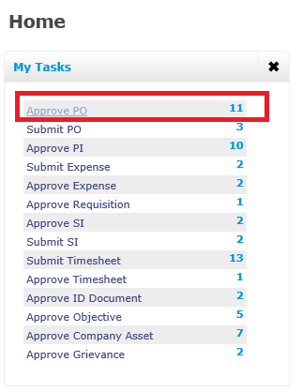
You will be taken to form showing list of requisitions/orders requiring approval – see below. Click on the date to open the purchase requisitions or order you just submitted.
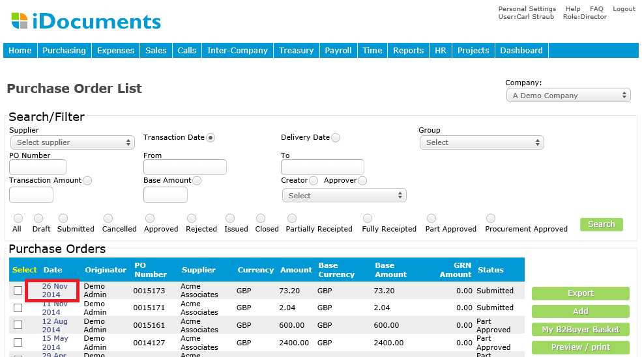
You can approve the requisitions or order by clicking Approve button – see below.
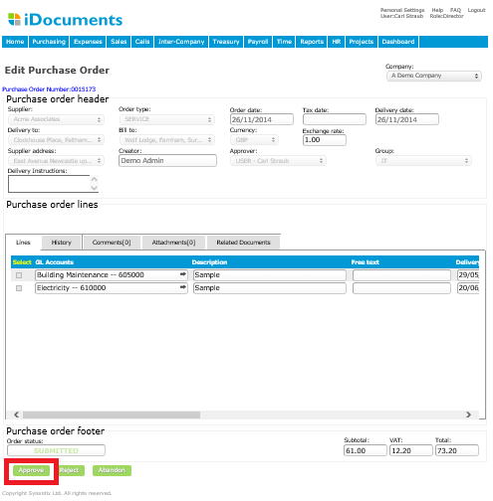

You will then be returned to the requisitions or order list showing documents to approve. If there are no further documents to approve then the list will be empty the Requisition/Order will be shown as Approved.

You can exit the transaction without saving your changes by clicking the Abandon button. This will return you to the requisitions or order list.

Purchase Order - Once an approved PO is synchronized with your Accounting or ERP system It will display the PO number.

Purchase Requisition - a requisition can be picked up and if required, consolidated with other requisitions from the same Supplier before it is converted to a purchase order, it therefore does not post to your Accounting or ERP system.

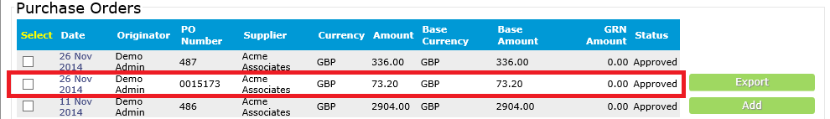

Rejecting a Purchase Requisition or Purchase Order
As part of the approval process, you can Reject a purchase order by clicking the Reject button and noting the rejection reason. The purchase requisition or order will be listed as status Rejected and automatically be referred back to the person who originated it.
If you have had a purchase requisition or order Rejected, it will appear as a Submit Order in your Task List and as status Rejected in the list view. Open the order and click on the Comments tab to view the rejection notes added by the Approver. You can respond by adding comments and submitting the purchase requisition or order again.

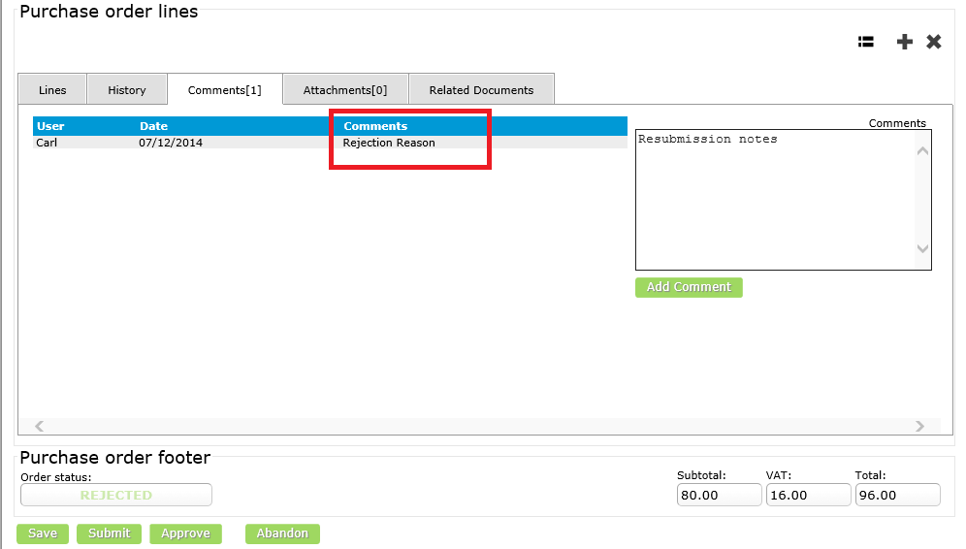
Creating a Purchase Order from a Requisition
Select Add New Order under the Purchasing menu and click the Select Requisition button.
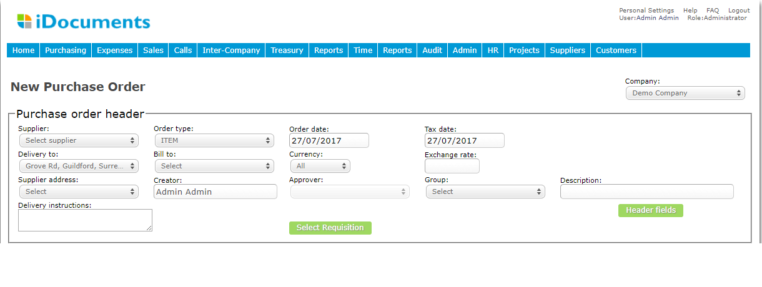
You will be presented with a list of approved purchase requisitions to select from. Select the requisitions you wish to pull in to the purchase order by clicking the Select tick box in the Purchase Requisitions list and click Next. Note: requisitions selected should be to a common Supplier.

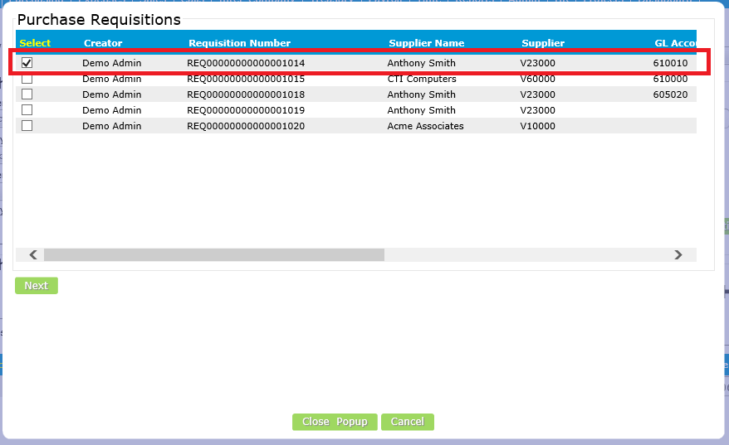

Select the Supplier from the Suppliers drop-down list and Finish.
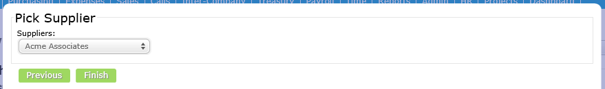
The requisition lines will be pulled into the order and at this point they can be amended as required.
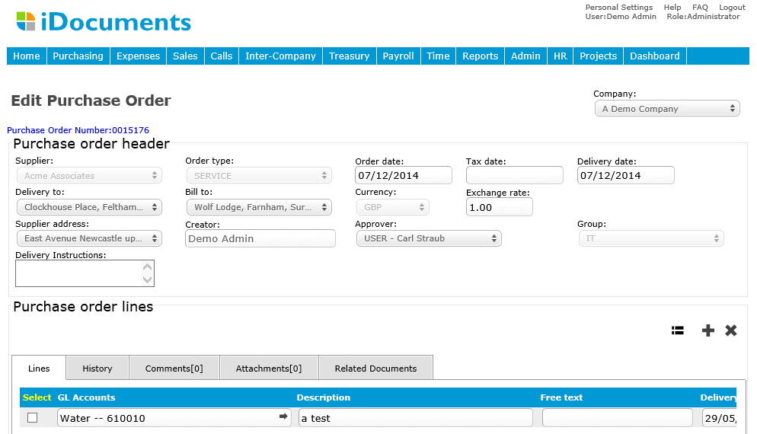
Once the order is complete, Submit. The purchase order will be submitted to the appropriate purchase order approval workflow.

Sending Purchase Order to Supplier
After approvals are completed, the document creator would be notified by email. Purchase order status can be viewed under the Orders menu.

Note: Orders can be automatically sent to suppliers by selecting and clicking email button – the supplier email address that is set up in your Accounts or ERP system will be used.
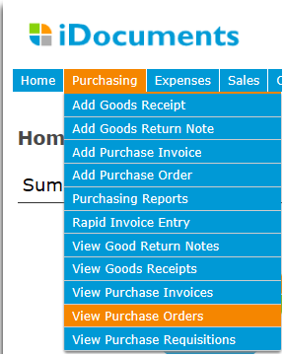
You will be taken to the Purchase Order List screen – where you can sort the invoice by fields at the top of each column.

Note: documents are only assigned a purchase order number after they are fully Approved.
Click the Select box next to the order you wish to send and click Email/Issue.
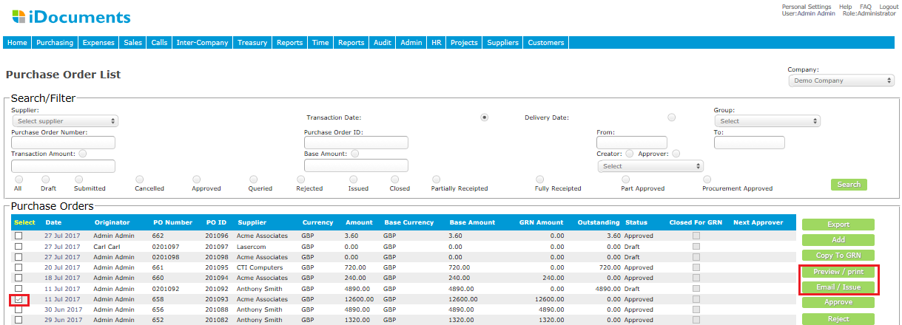
By ticking the box under Select and then clicking Preview/Print you can see the purchase order in PDF format.

Note – you must have Adobe Reader on you PC to be able to do this.
The PDF will appear in a Window as shown below.
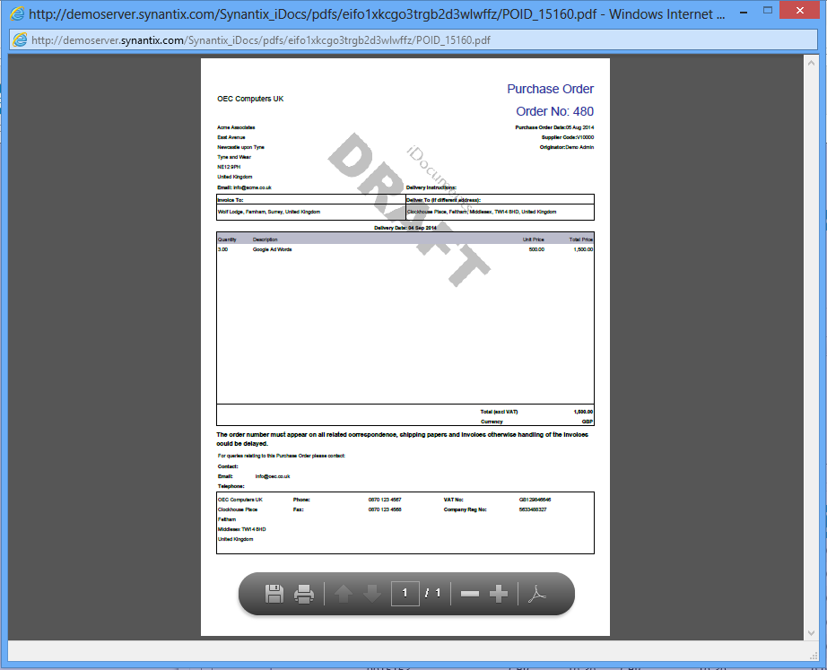
From this point you can Print or Save the PDF.

Email/Issue button can be set up to allow you to enter up to 5 email address to email Purchase Order – see screen shot below. The PO is then set to status Email Issued and in the document history is saved when the PO was emailed, by who it was sent and who it was sent to. [NB this is controlled by Company Settings].

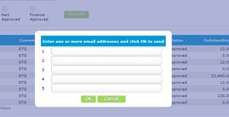
Goods Receipts Notes
From the Purchasing menu select Add Goods Receipt Note. Select the Supplier and Group and click the Select PO button for a list of open purchase orders relating to that supplier. Selecting the appropriate purchase order from the list presented will populate the goods receipt with information from the purchase order.
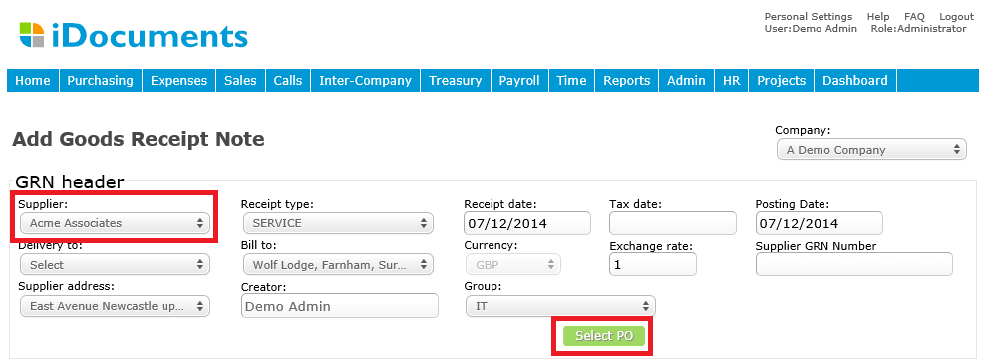
Tick the purchase order you want to GRN from the list presented and click OK.
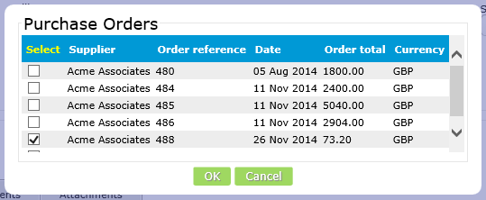
This will populate the goods receipt with information from the purchase order.
Enter a value in the Quantity Received field and click Issue at the bottom of the form. 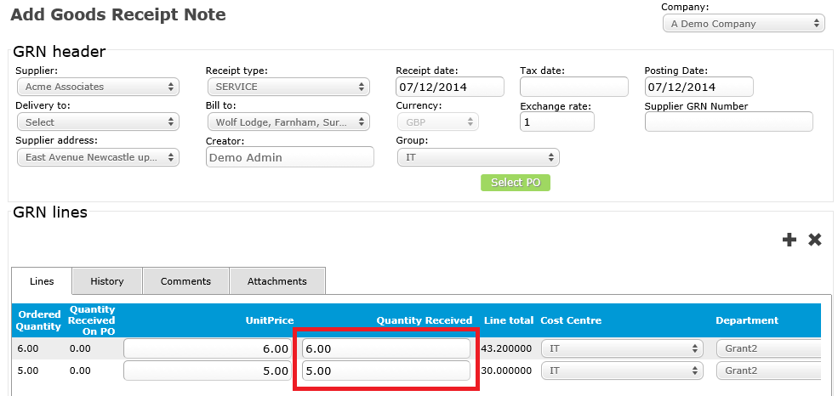

From the Purchasing menu select View Purchase Orders. Select a fully approved purchase order, and then select the Copy to GRN button.
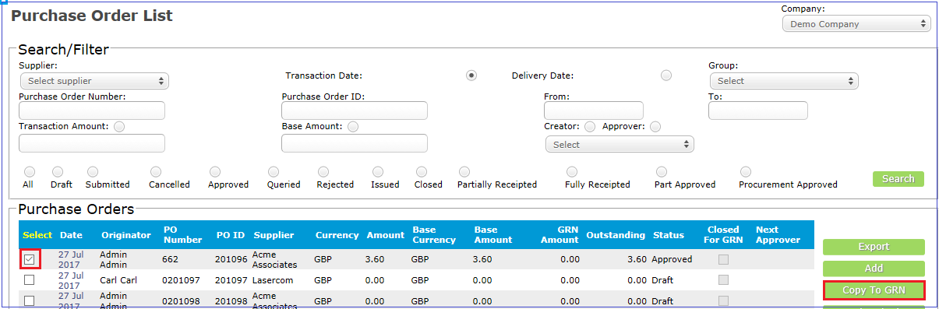

This will populate the goods receipt with information from the purchase order.
Enter a value in the Quantity Received field and click Issue at the bottom of the form.
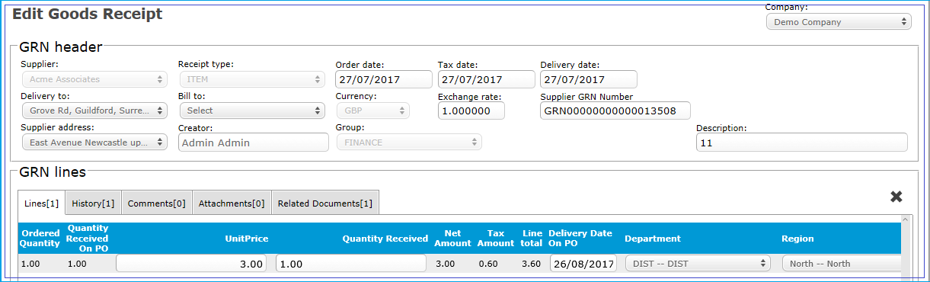

Goods Return Note
From the Purchasing menu select Add Goods Return Note. Select the Supplier and Group and click the Select GRN button for a list of goods receipts notes relating to that supplier. Selecting the appropriate goods receipts note from the list presented will populate the goods return with information from the goods receipts note.
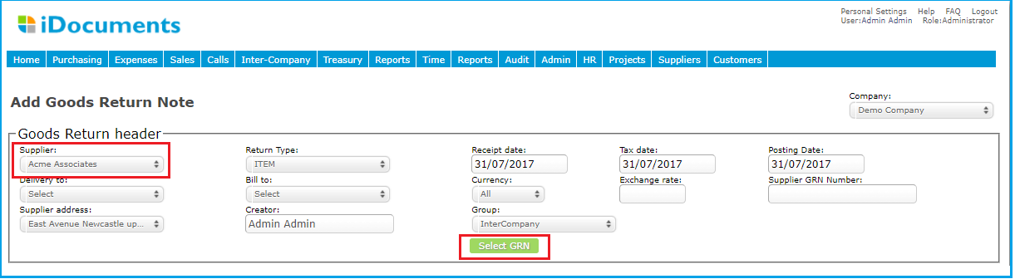

Tick the GRN you want to goods return from the list presented and click OK.
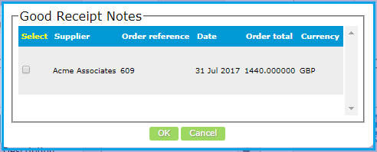
This will populate the goods return with information from the GRN.
Enter a value in the Quantity Returned field and click Issue at the bottom of the form.
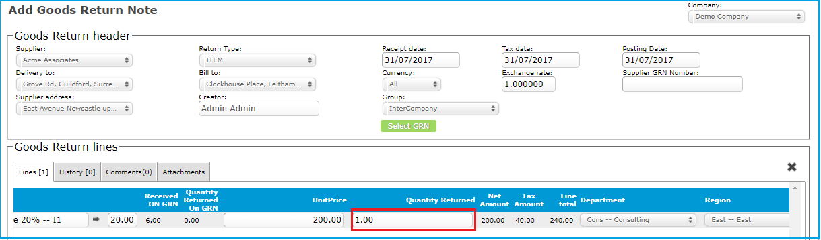

Processing Purchase Invoices
Login as the assigned Rapid Invoice user to process scanned invoices.
Supplier invoices are scanned and shown in your Tasks box as New Scans.
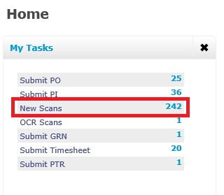
Click on the New Scans link for list of scanned invoice images which are ready to code and match. You could also select Rapid Invoice Entry from the Purchasing menu.

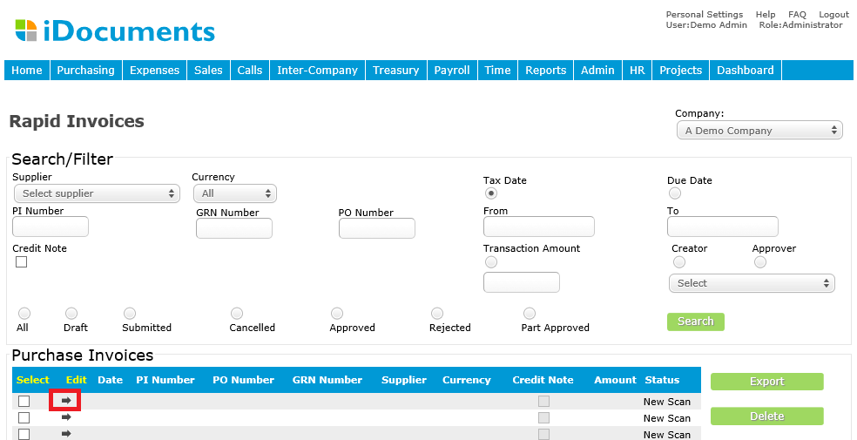
Click the Edit arrow for a New Scan, to commence the PO/PI matching process.
You will be presented with the following form, which shows the scanned invoice on the right hand side.
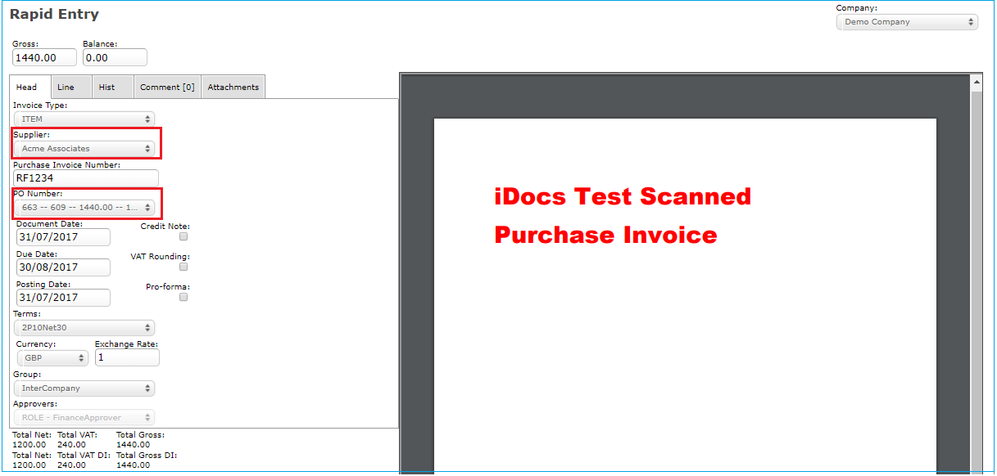

Click on the Supplier field to select the name of the supplier on the purchase invoice.
Click on the PO Number field. This will list any open purchase orders for that supplier that have been fully Approved and Finance Approved. Select the one you require. The purchase order will be automatically pulled into the Rapid Entry form. The Group the order was created from will be pulled in (this will determine the approval process).
Enter the Purchase Invoice Number and select a Document Date.

PLEASE NOTE this is the process for manual purchase invoice coding. If iDocuments Intelligent Capture is integrated and supplier templates are set up, fields will be pre-populated.

If a Purchase Invoices matches Purchase Order
If the PI matches the PO exactly enter the gross value in the Gross field and the Balance field will display as 0. Note: the Balance field must always be 0 before you can Submit a PI.
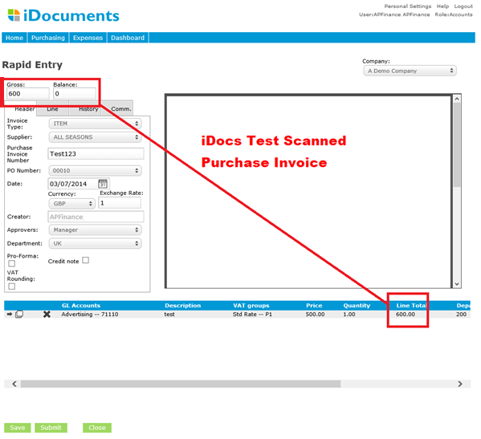

Submit will result in:
- If the system setting ‘Send PI to PO creator’ = Y and the approval workflow has the Function = ‘Originator’ as the first step. This will create a PI with status Submitted. It will also trigger the PI approval process and an email alert will be sent to the purchase order creator. The purchase invoice will appear as an Approve PI Task to confirm approval for payment or Reject.
- If the system setting and approval workflow have not been configured as above, the PI will be automatically approved.

If a Purchase Invoice does not match Purchase Order
When you selected a PO from the drop-down you will see that the PO lines were displayed at the bottom of the screen.
Click on the arrow for the purchase order line that does not match. This will pull the PO line details into the Line tab.
Click on the Line tab and you will see the Net value of the line in the Price field. In this example, the Net on the line was 500 and the Gross on the line was £600.
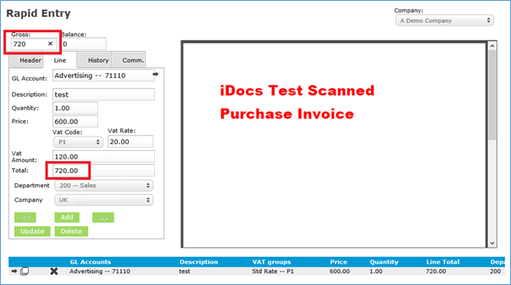
So for example, if the invoice is for £600 for that item rather than £500 on the PO, you would type £600 into the Price field and click Update. This will update the line Total to £720.
Click on the Gross field and type in 720 to leave a Balance of 0 and when you have finished coding the Invoice Submit. The update in the line value will trigger the PI approval process and the PI will be sent through the PI approval workflow before it can be Approved or Rejected.

If there is no Purchase Order
Click on the New Scans link for list of scanned invoice images and click the Edit arrow for a New Scan.
Complete the Header fields excluding PO Number.
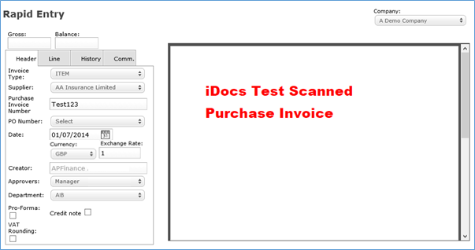
Click on the Line tab to complete the PI line details and Add. Continue to add lines as required, and click Submit when complete.
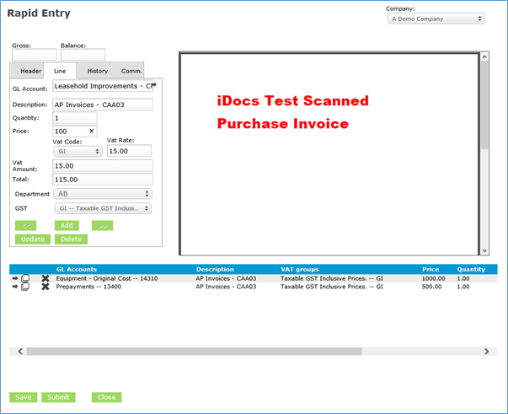
The purchase invoice will be sent through the PI approval workflow before it can be Approved or Rejected.

