Absence Management

Introduction

Absence can be monitored within iDocuments under four variations:

- Public Leave - non-working days, where allowance is not deducted
- Personal Leave (Holiday) - where allowance is deducted (e.g. holiday, vacation)
- Personal Leave – where allowance is not deducted (e.g. Doctor or Dental appointment)
- Sickness - where allowance is not deducted
- Compulsory Days – for Company closures, for example, between Xmas and New Year where allowance is deducted from all employees

Public holidays are automated from the assigned working pattern. All other absence follows the same structure, whereby the user may request the time of absence by submitting for approval to either line manager or HR. Each absence requires single approval and does NOT follow any approval workflow as they are company and group independent (i.e., if you are off you are off no matter of association).

The absence module integrates neatly into the timesheets and project planning by feeding the information automatically to them. For example, holidays are shown on the timesheet to reduce the total number of hours for declaration.

Leave
The leave types can be maintained by an administrator to define the options for selection and those which will deduct from the holiday balance, those which will deduct from the flexi balance and those which are in essence “free holiday” deducting from neither.

To request a period of planned absence, either the user themselves, the manager or any HR user may load the user profile and select the “Leave” section. From here the type of absence is selected along with the range in which the holiday is for – this can overlap weekends and non-working days as the system will account for those automatically.

Clicking “Confirm Dates” will present a grid to indicate the blocks in which a holiday is required allowing for AM, PM or both (full day) for selection and de-selection. Any days that the user is NOT expected to be working will be read-only and NOT count towards the total number of days being booked.

Holidays can ONLY be taken in full or half days where the remaining allowance left allows (see more details below) and where they do not overlap another leave and/or sickness record.

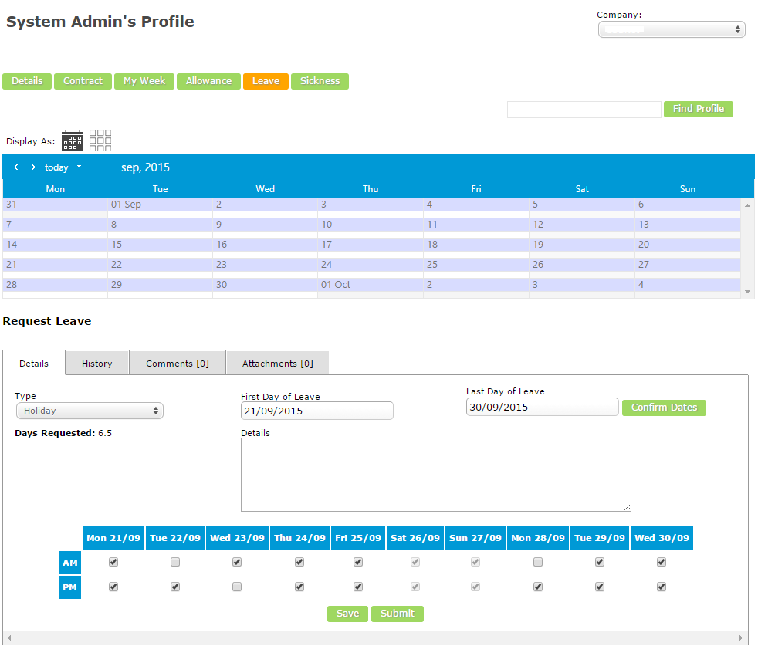

To assist in reviewing holiday a calendar of leave is presented at the top of the form which can be toggled to a grid view presentation. Right clicking the record on the calendar (or clicking the arrow when in grid display) will show the details below it allowing it to be submitted or cancelled.

The approving of absence is by line managers and/or HR and then depending on the configuration of the type of leave, a second step can be required for HR when the manager has approved at step 1.

Leave can be cancelled providing it has not started and in doing so any days are returned to the user as available balance (more details below).

Absence Rules
This facility define dates that are not permitted as leave, so they are denied upon request; which will stop any submission of the date for approval automatically. In addition, dates can be defined as ‘Mandatory’, such as a Compulsory Days e.g. closure between Xmas and New Year, and are automatically deducted from the user starting balance.
These rules are defined by system ‘Administrators’ and can be user-specific, by being applied to chosen Holiday allowances to then filtered to the applicable users.

Balance Reporting

Each user is granted a starting balance based on the holiday allowance they have been allocated and the date in which they joined the organisation in conjunction with the current holiday year. For example, if a year runs from 1st January to 31st December and the user was present on 1st January they would be granted a full allowance of 24 days but a user who started on 1st March would be granted only 20 days (24 basic / 12 months = 2 days accrued per month * 2 months not present = 4 days deducted from basic starting balance).

The same logic is applied when a user is set with a leaving date so that the balance is reduced on the run up to the last day of working.

When booking and calculating balance the following ordering and logic is applied:
- Review the working pattern and public holidays for the total number of days to be booked
- If of type “Holiday” (until all days are booked)
  - Deduct any remaining days from the “Carry Over” if within the month range of use
  - Deduct from remaining core balance
  - If required, deduct from the “Carry Under” reducing the next year to the limit allowed
  - Deduct additions until the maximum negative balance has been reached
  - If all days are accounted for, proceed with booking
- If of type “Flexi”
  - Calculate based on working pattern the total number of hours required for each day and/or half day to obtain a total number of hours required for booking
  - If enough hours have been accrued on previous timesheets, proceed with the booking
- Else, proceed with booking
Any holiday cancelled will return all the days booked back to the section in which they were taken from but can only be done if the holiday has yet to begin (i.e., start date not reached).

The balance for each user for each year can be reviewed from the users profile under the “Allowance” section as one row per year. This gives a breakdown of each section of allowance with a grand total possible at the end.

Should the figure be incorrect or for any reason an addition or reduction is required then the adjustment can be fed in and saved with the blue arrow using a minus sign to reduce the total. Flexitime however is a single figure so rather than an adjustment, the total should just be updated and can also run into negatives by the use of a minus sign.

On making any adjustments a reason must be entered which can be reviewed from the “Adjustment Log” link.
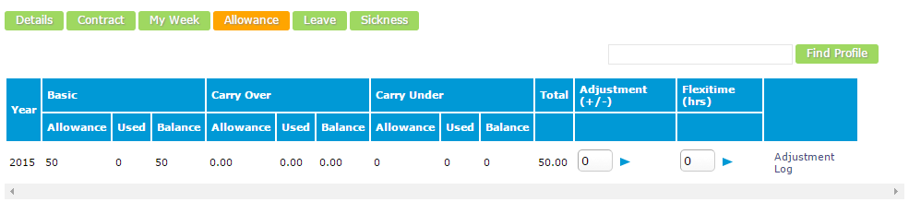
Rolling to the next holiday year will review each user for the basic starting balance, then deduct any days used in the preceeding year to obtain a new starting balance. The configuration applied to the user on the 1st day of the new year is then applied for carry over and negative allowances preparing the system for use in the next year.

Sickness
The sickness types can be maintained by an administrator to define the options for selection and such absence have no effect on any holiday balances and are instead a record of un-authorised absence.

To report a period of absence, either the user themselves, the manager or any HR user may load the user profile and select the “Sickness” section. From here the type of absence is selected along with the range in which the absence began and is likely to end – this can overlap weekends and non-working days as the system will account for those automatically.

Should a sickness end date be unknown, the record should remain in “Draft” until the employee returns to work at which point the end date can be regularly updated and then finally submitted and approved.

Clicking “Confirm Dates” will present a grid to indicate the blocks in which days are applicable allowing for AM, PM or both (full day) for selection and de-selection. Any days that the user is NOT expected to be working will be read-only and NOT count towards the total number of days being booked unless the sickness type does not validate the working pattern.

Sickness can ONLY be taken in full or half days where they do not overlap another leave and/or sickness record.

To assist in reviewing sickness a calendar is presented at the top of the form which can be toggled to a grid view presentation. Right clicking the record on the calendar (or clicking the arrow when in grid display) will show the details below it allowing it to be submitted or cancelled.

The approving of sickness is by line managers and/or HR and then depending on the configuration of the type of leave a second step can be required for HR when the manager has approved at step 1 (see more details below under the “Calendar” details).

Once a sickness document has been approved it also requires self-certification from the employee (this is automated when the employee instigated the record). On the homepage there will remain a task to certify the sickness which just requires the employee to confirm all information added by the manager/HR was accurate in order to countersign the approval.

Sickness can be cancelled providing it has not started in which case it can simply have the dates amended.

Calendar

For a full presentation of all absence (leave and sick) the calendar can be loaded, initially for the logged in user but where a managerial association or HR role exists can be filtered to more users.

The calendar differentiates the absence types and statuses by colour coding and defines expected working days as white, shading them grey where either a public holiday occurs for the user or a non-working day.
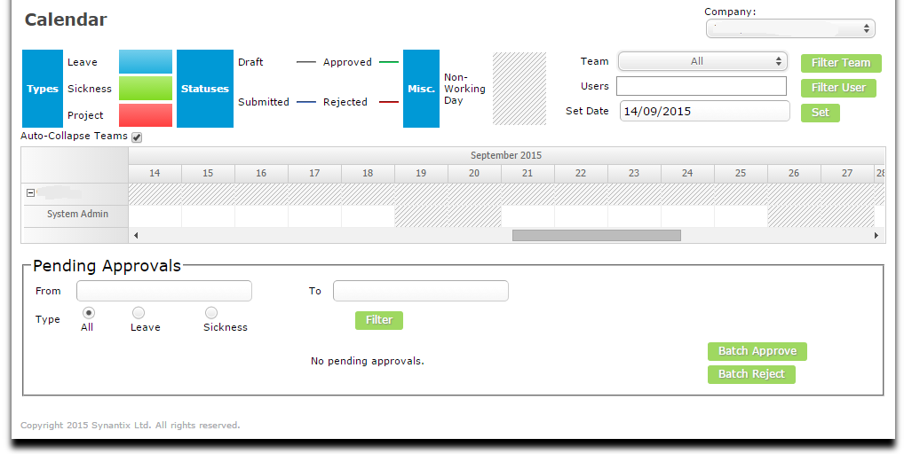
The left hand column shows a tree view of the teams with one row per user allowing the filters of team, user and dates to be applied.

Depending on the access rights of the logged in user the records can be hovered over for more details and right clicked to load.

The final purpose of the calendar is for absence approvals. Although the individual absence can be found on the users profile this page collates all user and all absences in one single view allowing for filtering, loading and a “Batch Approve” by ticking the required rows. When a batch rejection is being made a reason is still required and will be reported as such for each absence selected.

Email Notifications

An extensive emailing matrix is available so the administrator can define by type, status and recipient what the subject and body of the email should be including if it is not required.

This matrix is defined on the leave and sickness types setup where an initial default can be applied and then altered by type. If an email is required then a subject and body should be entered, if not it should be left blank. At that point all absences will use this configuration but selecting the type specific configurations can be made by unticking the “inherit” and entering a new subject and body if different or removing them to stop the notification.

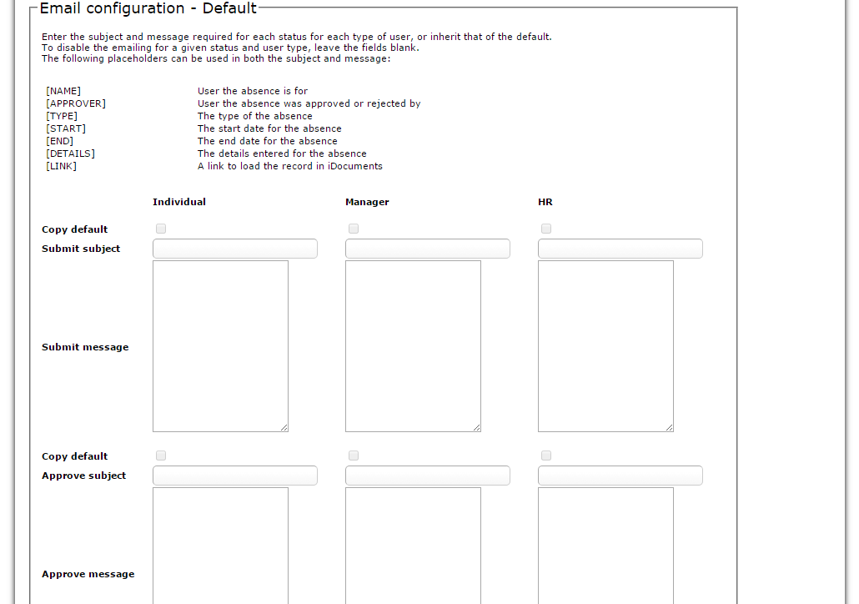

Finally, placeholders as described on the page can be used to configure the email appropriately – these can be used in both the subject and the body.

Reporting

As both a manager and a HR user there are a variety of standard reports available all of which are pre-filtered to show only those employees of interest (i.e., those you manage). All of the reports can be displayed to screen and exported to csv file for further review.

The reports are:
- Absence analysis – ‘Bradford Factor’ summary; The Bradford factor is calculated using the Bradford Formula S2 x D = B, where ‘S’ is the total number of separate absences by an individual and ‘D’ is the total number of days of absence of that individual. ‘B’ is the Bradford Factor score. Fields: Company, ID, Name, Number of absences, Number of absence Days, Bradford Factor.
- Configuration & Holiday Balances – a grouped report to show how each user is configured with working pattern, public leave and allowances. Also shows the status of the Holiday balance to current date.
- Absence Summary – filtered by team, user, types and dates it shows all absences reported.
- Adjustment Log – summary of changes made to Holiday balances.
- Sickness Certification – shows all those sicknesses reported that have yet to have been certified along with the dates of those which have been certified.
- Weekly flexi balances – to aid with the flexi values displayed on the timesheet and user profile records this report will present a rolling total of each week per user based on the required hours

